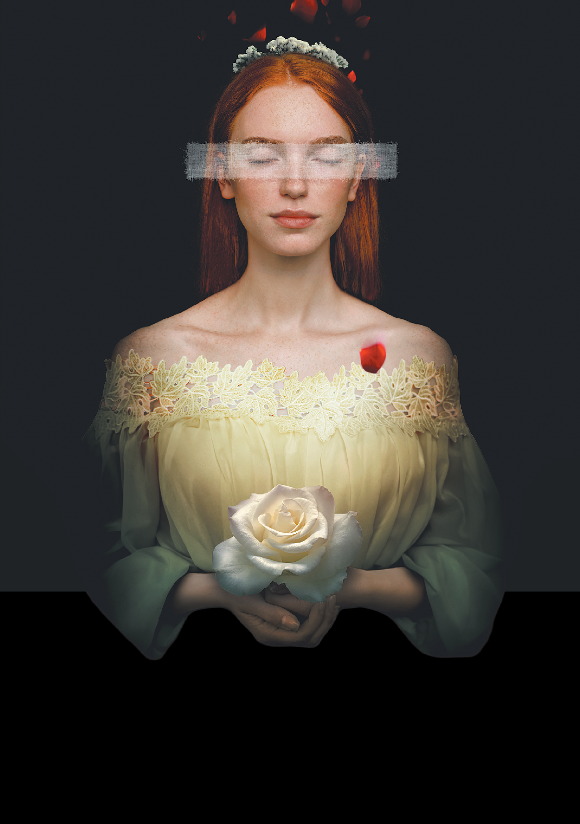

IOLANTA

TCHAIKOVSKY

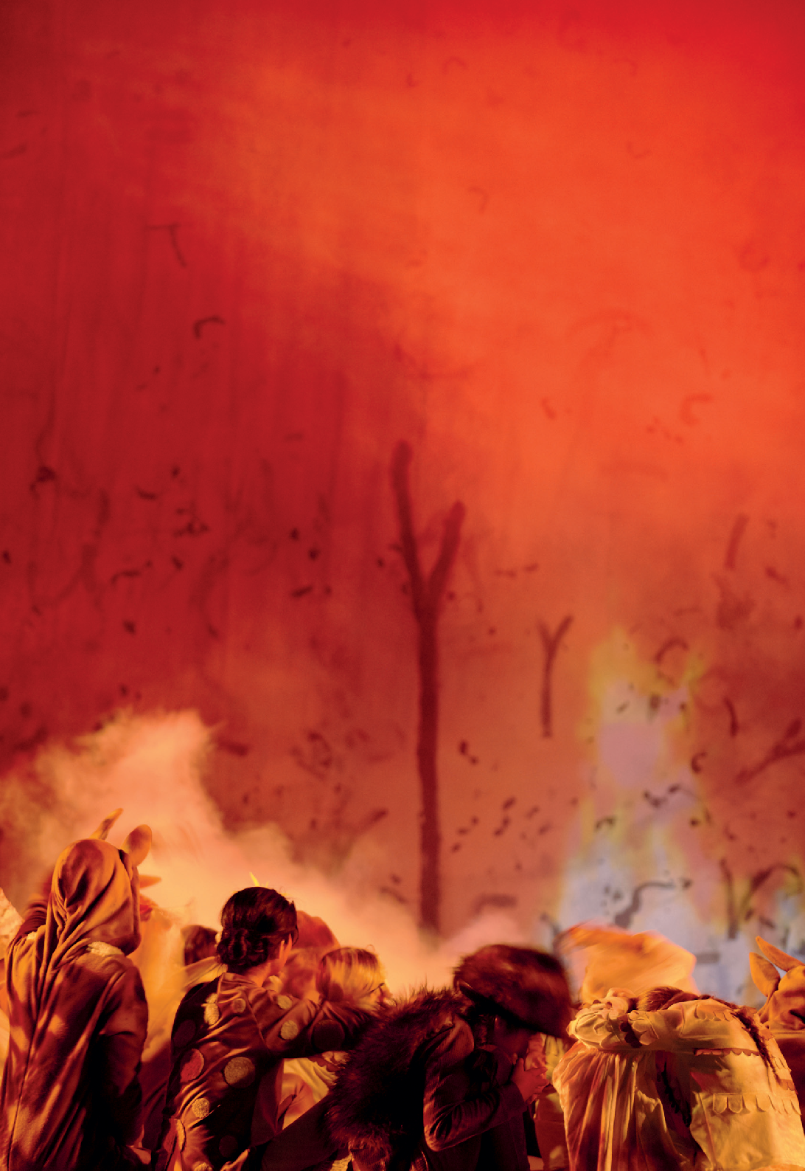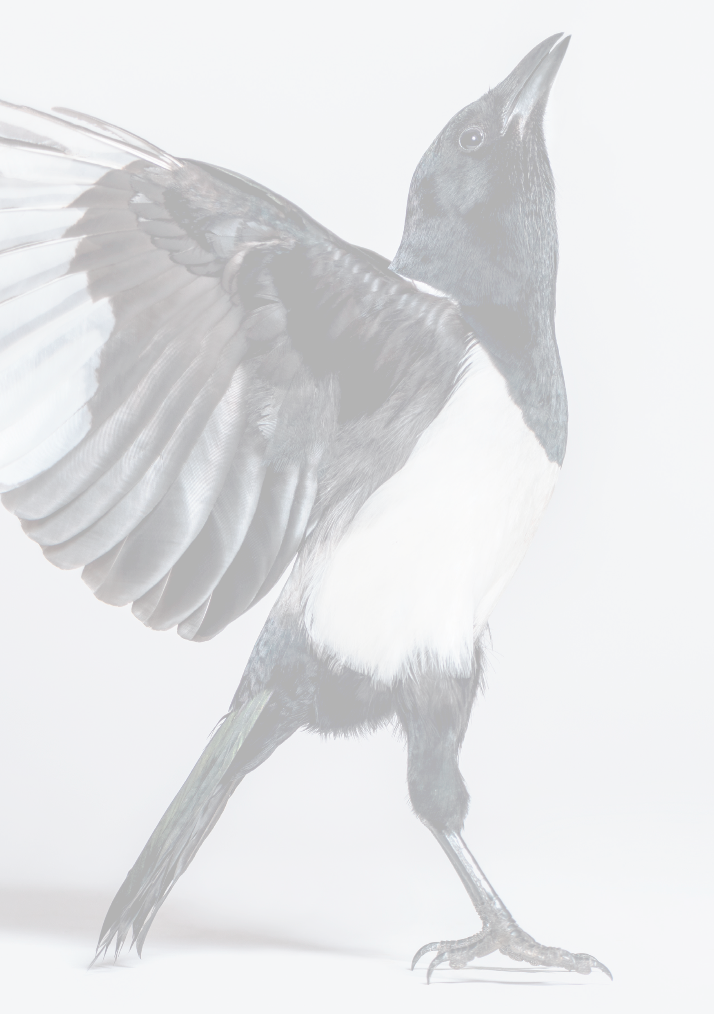
Creativity in flight

As Principal Partner of West Australian Opera, and commissioning partner of Koolbardi wer Wardong,
Wesfarmers is helping Western Australian stories take flight.

Celebrating the indigenous culture of this place on Nyungar Country, Koolbardi wer Wardong speaks uniquely to this land, time and place.
Wesfarmers Arts is privileged to commission major
new works that help our arts sector re-emerge from the crisis of COVID-19, resilient, re-invigorated and connecting afresh with audiences
around our state.

WESFARMERS ARTS COMMISSIONING PARTNER OF KOOLBARDi WER WARDONG, TOURING WESTERN AUSTRALIA IN 2022

IOLANTA

6, 7, 8, 9 April 2022
His Majesty’s Theatre, Perth
Composer Pyotr Ilyich Tchaikovsky Conductor Christopher van Tuinen Director Katt Osborne
Set and Costume Designer Tyler Hill Lighting Designer Michael Rippon Sound Designer Jeremy Turner
Creative Development / Libretto Katt Osborne and Zel Iscel
Setting of Libretto Lea Hayward Chorus Master Christopher van Tuinen Repetiteur Lea Hayward
Iolanta Elena Perroni
Queen Iolanta Grace King Count Vaudémont Paul O’Neill Brigitte Chelsea Burns
Laura Fiona Campbell
Marta Brigitte Heuser Duke Robert Lachlann Lawton King René Adrian Tamburini
Ibn-Hakia (The Doctor) Simon Meadows
Bertrand Callen Dellar
Alméric Matthew Reardon
Featuring West Australian Opera Chorus
Featuring West Australian Symphony Orchestra
Production Manager Mandy Farmer
Stage Manager Karen Farmer Deputy Stage Manager Jacinta Wajon Assistant Stage Manager Erryn Hanson Assistant Stage Manager Rose Liggins
Head of Wardrobe Sue Kerr Wardrobe Assistant Nora Stelter Wardrobe Assistant Rose Finlay Dresser Meg McKay
Wardrobe Maintenance Brooklyn Rowcroft
Head of Wigs Virginia Hawdon Wigs Assistant Delia Stanley Milliner Susi Rigg
Head of Make Up Sharon Kyrwood Costume Props Maker Louise Grimshaw Scenery built by Plumb Artsworkshop Head Mechanist Ian Studham
Surtitle Operator Allison Fyfe
Information is correct at the time of publication but may be subject to changes.

Vice Regal Patron’s Message
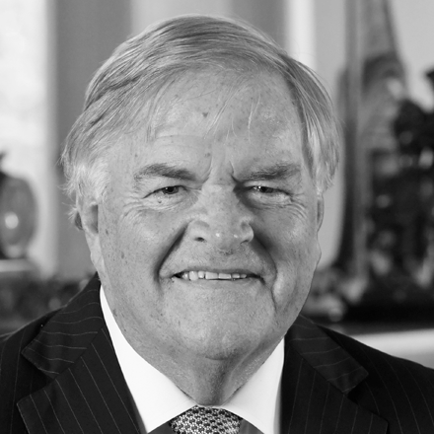
As Vice Regal Patron of West Australian Opera (WAO), I am pleased to see the state opera company presenting this wonderful example of community collaboration between Disability in the Arts, Disadvantage in the Arts, Australia (DADAA), the blind and vision impaired community and WAO.
This is the story of a blind princess, Iolanta, who lives guarded from awareness that sight is even a sense; a ruling by her father, the King. Witness the story of a young woman who is held captive, not by her blindness, but by the ignorance and assumptions of those around her.
As the state opera company, West Australian Opera contributes to the arts in Western Australia by presenting world-class opera at His Majesty’s Theatre, offering education and community programs, school workshops, regional touring and developing young artists through the Wesfarmers Arts Young Artist Program.
The company’s excellence is recognised through the generous support of both State and Federal governments, Principal Partner Wesfarmers Arts and private donors and corporate supporters.
I wish all involved in bringing Iolanta to the stage every success.

The Honourable Kim Beazley AC Governor of Western Australia Vice Regal Patron
West Australian Opera

Executive Director’s Message
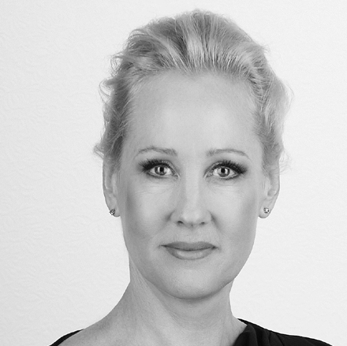
Tchaikovsky’s beautiful musical score sets the scene through soaring voices and sweeping melodies as we discover the world from a new perspective.
Katt Osborne and Zel Iscel have co-written the libretto and, with Chris van Tuinen, Tyler Hill, Michael Rippon and Jeremy Turner, have led the company through creative development to tell this story from Iolanta’s perspective.
We acknowledge and thank focus group participants and DADAA for their
contributions to this work which has been in development for two years.
Katt Osborne has directed this work with Chris van Tuinen conducting our team including Elena Perroni, Grace King, Paul O’Neill, Chelsea Burns, Fiona Campbell, Brigitte Heuser, Lachlann Lawton, Adrian Tamburini, Simon Meadows, Callen Dellar, Matthew Reardon, the West Australian Opera Chorus and the West Australian Symphony Orchestra.
Thank you for supporting West Australian Opera as we continue to navigate through this new and changed world. Looking at the world through new prisms is important and the arts can help us understand this. Stay safe and thank you for your understanding and adherence to COVID-19 safety measures.

Carolyn Chard AM Executive Director West Australian Opera

Chairman’s Message
As Chairman of West Australian Opera, I am proud that we are able to present Tchaikovsky’s
Iolanta in a new production developed here in Perth.
We appreciate that we are able to present work live in the theatre under the present Western Australian State Government’s Level 1 measures and we thank you for your understanding in assisting COVID-19 safety.
We welcome and thank the cast and creative team, the West Australian Symphony Orchestra and West Australian Opera Chorus and our collaborators at DADAA.
We recognise Principal Partner Wesfarmers Arts for their longstanding support and we thank Major Partners Lotterywest, Healthway, the Minderoo Foundation and Civic Partner the City of Perth for their valued contribution.
We are grateful for the continued support of the Federal Government through the Australia Council and the State Government through the Department of Local Government, Sport and Cultural Industries.
Thank you to our donors, patrons and subscribers. We acknowledge your valuable support and encouragement which plays an important role in the life of West Australian Opera and its ecology within the arts and cultural landscape of Western Australia.

Andrew Pascoe Chairman
West Australian Opera

Conductor’s Notes
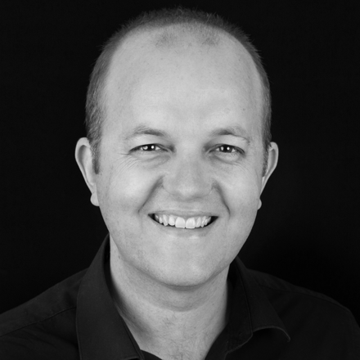

Opera companies have long examined the context and perspective of composers and librettists at the time of writing, questioning the relevance and authenticity of their works and those perspectives against our time.
When revisiting a work, one questions what the work itself says, then questions whether the original authors created the work from an appropriate or informed perspective. The narrowest reading of this question states that only people with lived experience can talk on behalf of that experience.
Such a strict precondition would limit the powers of empathy, shared experience, observation, and fantasy. It would stop us using the remarkable talents of authors to connect and elaborate stories, talents that might not be present in the originators of those stories. I believe there needs to be a place for the imagination here, that authors don’t need to have strictly lived the experience before writing or composing about it.
What then needs to occur to ensure authenticity and respect is a collaborative process, involving engagement and consultation, listening, and being gifted various points of view.
We can look at the story of Iolanta as a simple example of “a barrier to a richer life is removed by the power of love”, but, in using the physical example of her blindness, the authors have opened a door into another world of lived experience.
Iolanta sings about how the world appears to her, what she suspects is going on and what her hopes are. The music is remarkable but the libretto is not, and what’s missing is an authentic voice around what Iolanta says. One example is that she doesn’t react to the deception by her father in an honest way, and instead of raging against the injustice and betrayal of those who hold power over her, the story moves her focus onto the threat to her new lover (who interestingly doesn’t care if she’s blind or not). Another is that she submits to a dangerous, painful, and frightening cure without the opera giving her time to consider her options or reject the coercion by those around her.
So why not park the piece and move onto less problematic ones? The answer is that there is a huge amount to love about the music and the story (despite its flaws).
Also, that in this time, we can work with communities to add their voices to this work, we can devise productions that include
and accommodate rather than ignore and minimise. Because it’s the duty of modern opera companies to cherish the traditions we’ve inherited and hand them on better than before.
It’s glorious, beautiful, and unique. I hope because of what we’ve done that it’s also more rounded and authentic, a truer version of itself for our time.

Christopher van Tuinen Conductor, Artistic Director

Creative Development and Libretto Notes
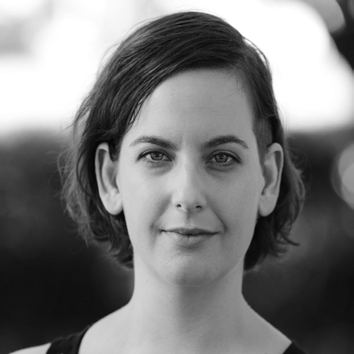
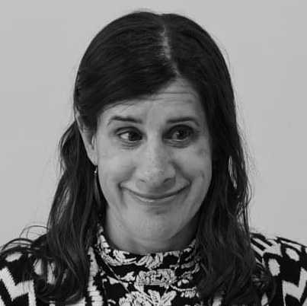

Tchaikovsky’s Iolanta is set in 15th century France, was written in 19th century Russia and has now been revised for performance in 21st century Australia. So, what does this mean?
We have approached our English translation and contemporary adaptation of the opera by centring the experience of Iolanta – the title character who is blind. Our goal from the beginning of our journey has been to share her experience and perspective as a person living with a disability, and to give our audience the opportunity to see things differently.
We discussed how we could further enrich the opera in our quest to make it as inclusive as we can. We explored the addition of certain sounds and smells throughout the show. We have included surtitles so that people who are deaf and hearing impaired can participate. We hope the experience we have created will be sensory and accessible to all.
As part of our creative process, we worked with a diverse group of blind and vision impaired local community members. We met several times in 2021 to discuss the story of Iolanta and to hear and share experiences within the group. Our job as co-adaptors was to reflect and take inspiration from these conversations and to find the best way to bring Iolanta’s point of view into the opera. We went through several concepts and drafts, receiving valuable feedback and input from the group along the way.
The story that you will hear today has been shaped by this process and we want to sincerely thank all the members of our focus group: Pam Barras, Richard Brider, Ben Clarke, Paul Crestani, Ally Gordon, Ryan Honschooten, Grace King and Emma Vardy. We’d also like to thank DADAA who helped champion and document the process.
We want to finally thank West Australian Opera for commissioning this world first. They whole heartedly backed the
process from the beginning. They listened and supported us and allowed us to be courageous and authentic.
It has been a privilege for us to reframe Tchaikovsky’s work and we invite you to experience Iolanta’s story, as the life-
changing events that occurred in her youth are re-told in her own words and through the beauty of rarely experienced music.

Katt Osborne & Zel Iscel Creative Development / Libretto

Designer’s Notes

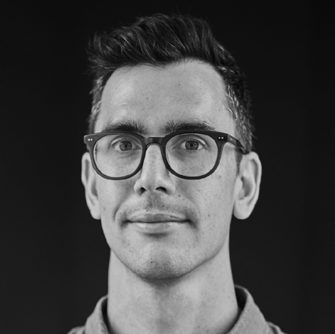

The deceptive tension between paradise and purgatory fuelled our designed sensory and accessible world of Iolanta, featuring symmetrical coarse curved stairs surrounded by ever shifting shadows and textures of the natural world.
There are multiple layers of historical contexts intertwined within the opera, which further activate our urge to distort and manipulate the design with darkness, colour, and form. The contexts range from the 1400s historical event Iolanta is based on, the late 1800s creation of the music and libretto, the early 1900s architecture of His Majesty’s Theatre and the 2022 contemporary adaptation.
The characters who retell Iolanta’s story are costumed to evoke memories, shapes and shadows of the medieval past linked to the original historical event fulfilling our impulse to reimagine and re-address Iolanta’s past experience of deception.
At the core of Iolanta is its delicate, yet soaring music, which our design amplifies with tactile and visually suggestive effect.

Tyler Hill
Set and Costume Designer

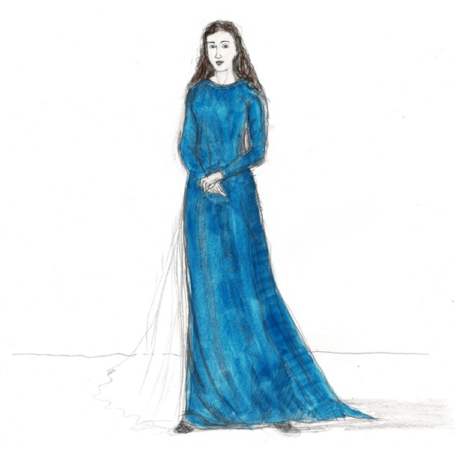
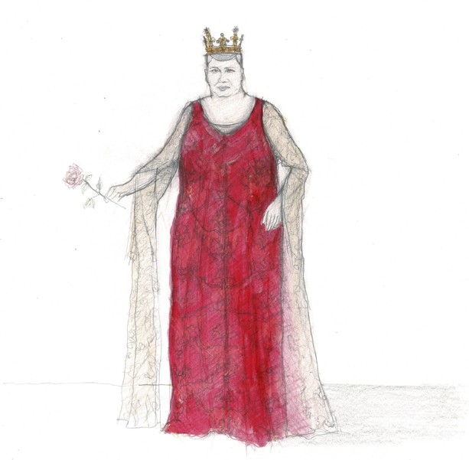

Iolanta wears a saturated ultramarine blue linen straight
line dress with her hair flowing loose.
Queen Iolanta wears a decorated regal straight line dress made of deep red raw silk finished with gold brocade stitching and rope details. Her crown is made of aluminum with a gold finish, jewels and a Fleur-de-lis pattern around the circumference.

Costume Descriptions

Find image descriptions for all characters via waopera.asn.au

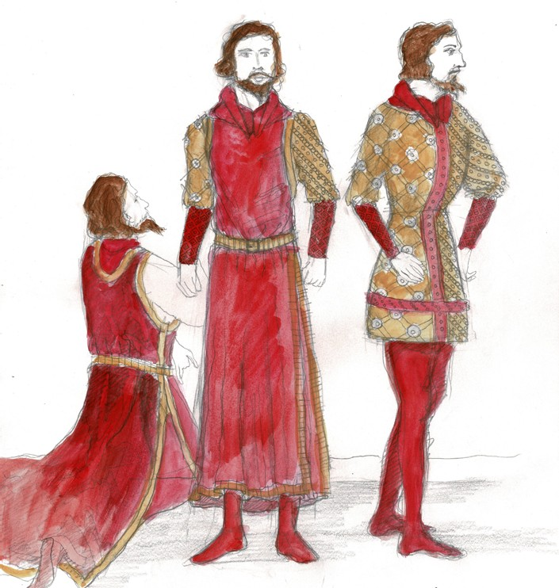
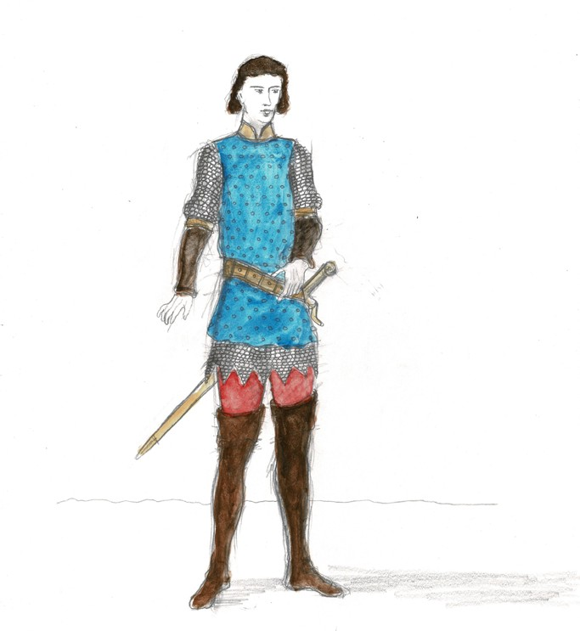

King René wears a dense deep red sleeveless tunic edged with gold trimming. Under the tunic is a bulky brass embossed leather shoulder sleeve and a tight-fitted gold forearm sleeve to finish the arm. His red knee-high boots continue up the leg with matching red tights. The costume is finished with a thick embossed gold belt.
Count Vaudémont wears a cobalt blue sleeveless tunic with chainmail sleeves and a jagged skirt underneath. The tunic is armoured with a gold belt, sword, sheath and scabbard (case for the blade of a sword). His brown leather knee high boots contrast with bright red leg tights.

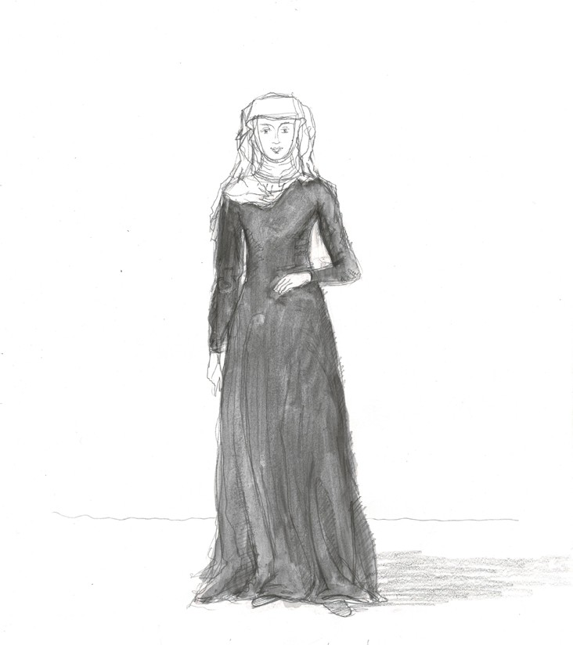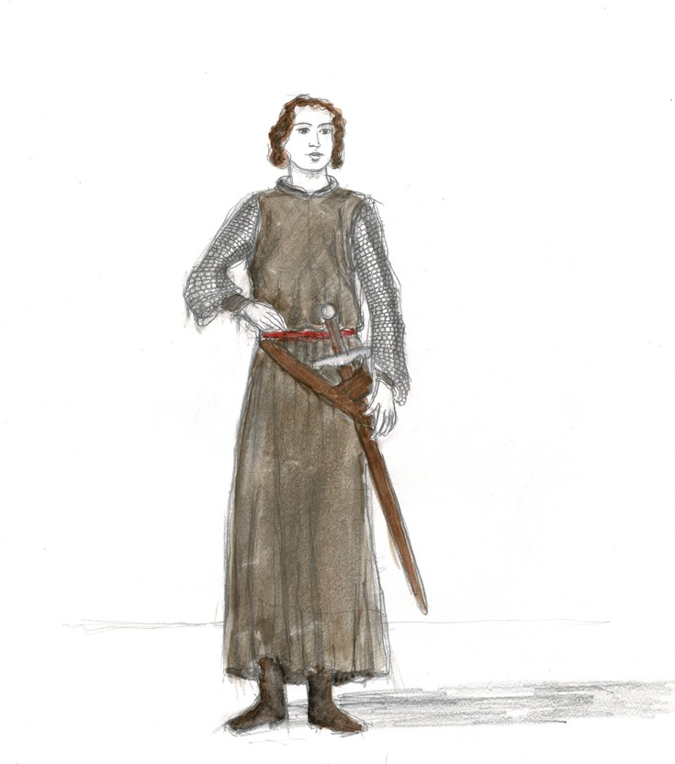

Marta wears a dark grey linen straight line dress with her hair covered by a head wrap, consisting of layers of off- white cotton gauzes.
Bertrand wears an earth brown textured long sleeveless tunic with chainmail sleeves, a thick red cloth belt and armour with a sword, sheath and scabbard (case for the blade of a sword) and brown leather boots.

Synopsis
Iolanta is blind but does not know it. She lives a sheltered life and knows only those who live with her. For the first sixteen years of her life, she wondered what the world outside her home was like. Why was she not allowed to explore the world? Why were others able to do things she was not? She has always known that something was missing. But what?
King René is Iolanta’s father. Iolanta only knows him as a knight, and not a King. She also doesn’t know that his greatest concern is for her to never learn that she is blind. He is determined to find a cure for her disability.
While searching for a cure, King René also seeks to conceal awareness of Iolanta’s blindness from her future husband, Robert. All those that serve the King and care for Iolanta - Marta, Bertrand and the maids – are sworn to secrecy.
A messenger, Alméric, arrives at Iolanta’s residence, announcing a visit from the King and a famous Doctor. The Doctor’s diagnosis is clear: Iolanta must be made aware of her blindness before deciding on any possible treatment. The King refutes this approach.
Robert and his friend, Count Vaudémont, stumble upon Iolanta’s home, unaware of who lives there. They are struck by its beauty but sense danger. They enter and meet Iolanta. Robert doesn’t realise she is his betrothed, whom he doesn’t want to marry because he loves someone else. Iolanta has not met many strangers in her life and is intrigued by the two men.
Increasingly anxious by the mystery of the place, Robert flees while Vaudémont stays, enthralled by Iolanta’s spirit. Vaudémont asks her to give him a red rose as a keepsake. Iolanta hands him a white rose, twice. Vaudémont realises that she can’t see. Iolanta has no idea what it means to ‘see’ in the way that Vaudémont does. They connect over their mutual curiosity and love of nature.
King René catches Vaudémont talking to Iolanta and is furious with him for revealing the secret to her. The penalty for revealing the secret is death. To save Vaudémont from her father’s fury, Iolanta agrees to endure any treatment performed by the Doctor.
After Iolanta and the Doctor leave, the King reveals to Vaudémont that he only threatened to kill him in order to inspire Iolanta’s desire to see and undergo the treatment.
Robert returns to save Vaudémont and realises that the girl he met is his betrothed. King René releases Robert from his commitment and gives Vaudémont his blessing to marry Iolanta if she regains her sight.
Iolanta and the Doctor return and share the news that Iolanta has been cured and can see.
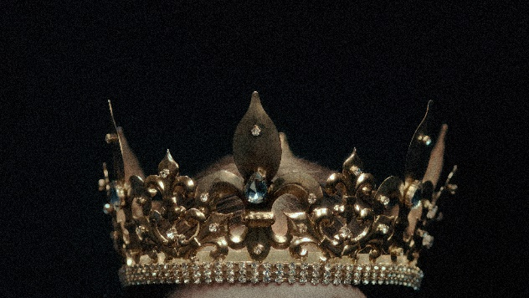
Vaudémont and Iolanta have the King’s blessing to be married and everyone praises God for the ‘miracle’ that has occurred…but are they celebrating for the same reason?

Iolanta: A Historical Perspective
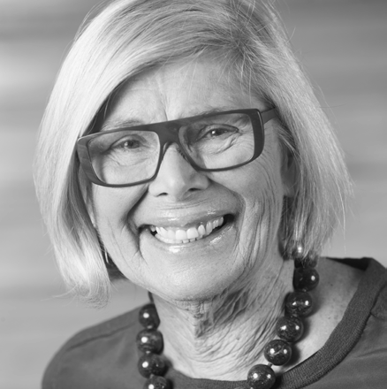

Tchaikovsky’s heroine, Iolanta, is probably unique in operatic literature: she was born blind. The story is based on Henrik Hertz’s play Kong Renés Datter (King René’s Daughter), translated from the original Danish into Russian by Fyodor Miller. The composer saw the play at Moscow’s Maly Theatre in 1880 and was inspired to write an opera on the same subject renamed Iolanta Opus 69. Modest, Tchaikovsky’s brother, who had written the libretto for The Queen of Spades Opus 68, was also commissioned to write the original libretto.
Storywise, Iolanta has no idea of her condition, or that she is a princess. Set in fifteenth century Provence, her father, King René, has confined her to a walled garden, surrounded by guardians (carers?) with entry forbidden to strangers on pain of death. She is literally ‘kept in the dark’.
The arrival of her father with a Moorish physician, Ibn-Hakia, brings hope that Iolanta’s sight might be restored. However, the doctor specifies that she be made aware of her misfortune and desire a cure which must be spiritual as well as physical. The King demures, but the arrival of Count Vaudémont introduces Iolanta to the meaning of the word ‘light’ in an impassioned aria.
The introduction, scored chromatically for woodwind and horns, sounds ominous, and evokes Iolanta’s world of darkness. This is followed by a string quartet and harp defining her gaining sight and emergence into light.
In fact, the harp symbolizes light throughout the opera.
Tchaikovsky was a symphonic as well as an opera composer and his use of orchestral colouring is particularly obvious in this, his last opera. His final symphony, No. 6 in B minor (Pathetic) Op.74 was composed shortly before his death in 1893.
Tchaikovsky’s Iolanta and his ballet The Nutcracker were premiered as a double-bill at the Mariinsky Theatre in St Petersburg on 18 December 1892 with Edmea and Nicola Figner as Iolanta and Vaudemont respectively (they had also created the roles of Tatiana and Lensky in Eugene Onegin Opus 24.) Tsar Alexander III attended the dress rehearsal and according to the composer “was visibly pleased, called me to his box, and was full of compliments.”
In this world premiere production we, the audience, will be taken on a journey through Tchaikovsky’s sumptuous music to discover the lived experience of the blind and vision impaired, and invited to see the world through their experiences. This will be an enlightening challenge for all.

Annie Patrick March 2022

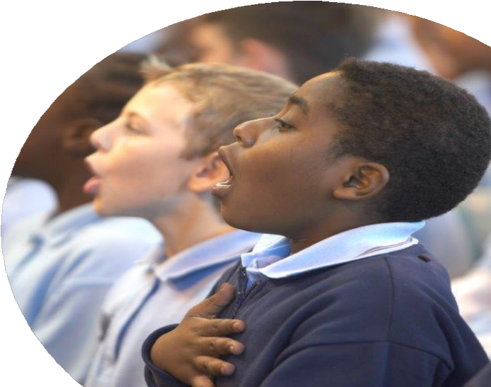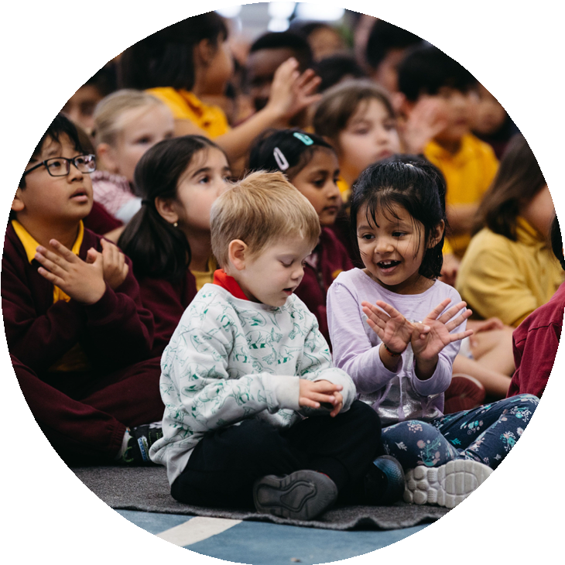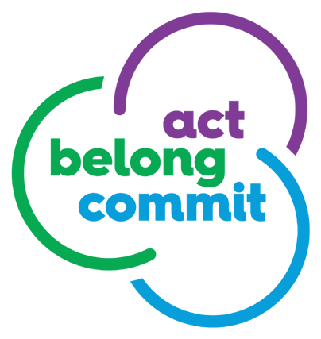

For ideas on how to keep mentally healthy, visit actbelongcommit.org.au
Through singing, young people
can explore their creativity

Discover WAO’s free digital singing lessons at www.learn.waopera.asn.au
and connect with others
Join Perry Joyce on a journey of vocal discovery to explore rhythm, tempo, pitch, dynamics and form.
Lessons are suitable for children 8-12 (and adults of all ages!)

Christopher van Tuinen

Conductor
Katt Osborne Director / Creative Development / Libretto

Zel Iscel

Creative Development / Libretto

Christopher graduated with a B.Mus from the Victorian
College of the Arts in 2001. In 2005 he completed a Masters in Conducting at the VCA. Experienced in both vocal and instrumental music he was awarded the John Williams Conducting Scholarship
for 2004-5. He also holds a
B.A. from the University of Queensland, an LLB from Q.U.T. and an A.Mus.A from the AMEB. He has been nominated by the Musical Theatre Guild for Best Music Direction and received a Green Room Award nomination in the ‘Best Conductor’ category.
During 2008 and 2009 he was a member of the Young Artists program as a Conductor with Opera Australia. In 2007 Chris was appointed as the inaugural Conducting Fellowship at the
Australian Ballet. He has worked with the WASO, Orchestra Victoria, AOBO and the QSO. His previous roles include WA State Manager for Musica
Viva, Classical Music Program Manager for Perth Festival, Chorus Director for WASO, Conductor of UWACS, Musical Director of Fremantle Chamber Orchestra and Artistic Director of Lost & Found Opera.
Chris is currently the Artistic Director of West Australian Opera.

Katt Osborne is a director, performance maker and creative producer. She was a co-founding artistic member of The Last Great Hunt, a 2018 Resident Artist (Director) with Black Swan State Theatre Company and
Co-Artistic Director of Riptide Youth Performance Company 2015-2020.
Notable credits include: DIRECTOR (OPERA/MUSICAL):
Western Sky Projects:
The Summer of Our Lives. West Australian Opera: The Telephone. Operabox: Ariadne Auf Naxos, The Old Maid & The Thief. DIRECTOR (THEATRE):
Performing Lines WA & PICA: Unheimlich. WAAPA: Love Me Tender. Riptide: The 1s, The 0s, And Everything In Between,
Walk With Me, Queen Leah. The Last Great Hunt: The Crossing, Elephents, Minnie & Mona Play Dead. PRODUCER (OPERA):
Lost and Found Opera: Acteon, Don Procopio. ASSOCIATE DIRECTOR: The Malthouse Theatre and Black Swan State Theatre Company: Cloudstreet. ASSISTANT DIRECTOR: Black
Swan State Theatre Company: Our Town, Xenides. The Old Vic: Dr Seuss’s The Lorax. AWARDS: 2016 WA Young Achiever of the Year for Arts; 2013 Fringe World Martin Sims Best New WA Work for Minnie & Mona Play Dead.
TRAINING: 2007 Bachelor of Arts Contemporary Performance.

Zel Iscel was born blind and arrived in Australia with her family at the age of six. She completed her degree in Politics and Government at Edith Cowan University in 2003 and became involved in disability advocacy whilst studying.
The role of art in changing culture and society became very obvious to Zel, but her access to all forms of the arts was very limited at that time.
After her graduation, Zel lived and worked in London for two years. There she was introduced to audio described theatre, where the visuals, including the actions, costumes and settings, are described.
Zel has become an ardent arts appreciator since, attending events including theatre productions, art exhibitions and festivals. She is also Secretary of DADAA. Zel currently runs her own consultancy, ‘Inclusive World’, where she provides disability awareness training, consultation on inclusive events and projects, and public speaking, among other things.
In 2021 Katt Osborne invited Zel to co-adapt Iolanta. This was
an opportunity she embraced with great enthusiasm and excitement, seeing it as a way to change negative attitudes toward blindness through art.

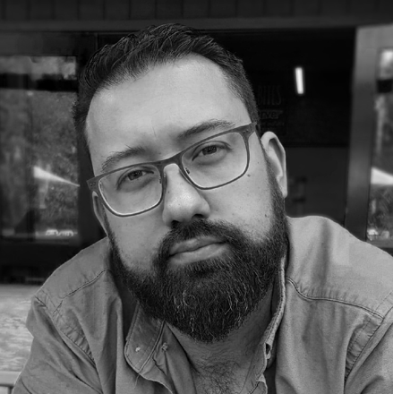

Tyler Hill

Set & Costume Designer

Tyler is a designer for live performance, exhibition, and film, who graduated from WAAPA (Set & Costume Design, 2016) and is an alumnus of the Black Swan Resident Artist Program (2018).
In only five years Tyler has designed for The Farm, Perth Festival, West Australian Opera, Sydney Theatre Company, Black Swan State Theatre Company, Barking Gecko, DADAA, Lost & Found Opera, The Blue Room Theatre, Spare Parts Puppet Theatre and WA Museum Boola Bardip.
His awards include the David Hough Award for Outstanding Achievement in Design (WAAPA, 2016), two PAWA awards for Best Design (2018 & 2019) and The Blue Room Award for Best Overall Design (2021).
As Design Associate, Assistant and a Draftsperson, Tyler has worked with Theatre Designers Zoë Atkinson and Elizabeth Gadsby, as well as in art departments on feature films The Furnace, Dirt Music and Otherlife.
Concurrently, Tyler is pursuing a Master of Architecture at the University of Western Australia.

Michael Rippon

Lighting Designer

After coming from the United Kingdom in 2001; Perth-based lighting designer Mick Rippon has worked in many venues and roles around the Perth theatre scene. During this time he has also toured productions through Australia and New Zealand.
Mick has designed lighting for Harmonike (Pulse Productions), Witches of Eastwick (9 Lives) and Strassman’s iTedE among others.
More recently he has been Lighting Designer for West Australian Ballet’s Quarry seasons in 2019 and 2020, The Nightingale (West Australian Opera) and Hymns For End Times (Perth Festival).
Mick has also worked as an Associate Lighting Designer for a re-light of Agatha Christie’s The Mousetrap in New Zealand for Lunchbox Theatrical and for West Australian Ballet’s seasons of Giselle (2019 + 2021), The Nutcracker (2020) and Dracula (2020 + 2021).

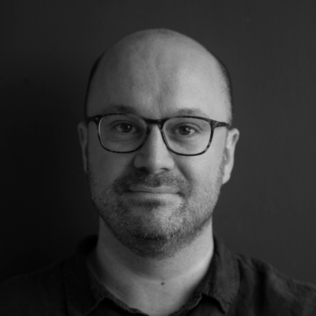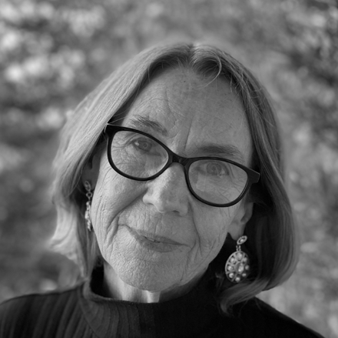

Jeremy Turner
Sound Designer

Lea Hayward

Setting of Libretto

Jeremy Turner is a sound designer and engineer, originally from Busselton and now based in Perth, Western Australia. He graduated from WA Academy
of Performing Arts in 2010 with an Advanced Diploma of Live Production, Theatre and Events (Sound), and has worked in a wide variety of theatre and live productions since then.
Formerly the Head of Sound & Audio-Visual for Perth Theatre Trust, he is now a freelance designer and engineer. Clients include Perth Festival, West Australian Opera, ABC Classic, Performing Lines WA, Yirra Yaakin Theatre Company, Perth International Jazz Festival, Musica Viva Australia and many more.
Recent sound design work includes Koolbardi wer Wardong (West Australian Opera, 2021), Escape (Perth Festival, 2022), Panawathi Girl (Yirra Yaakin Theatre Company, 2022), and Noongar Wonderland (Perth Festival, 2022).
Lea Hayward is an accompanist and repetiteur in the WA concert, opera, chorus and musical theatre scene.
Whilst studying at the NSW Conservatorium, she was repertoire pianist with legendary Australian mezzo Lauris Elms, and repetiteur for the world premiere of The Sentimental Bloke.
Returning to Perth, she worked with West Australian Opera, the G&S Society and Perth Light Opera Company, and played viola in WA Arts Orchestra and WA Symphony Orchestra.
Lea has accompanied many of Perth’s leading recitalists and, at the Opera Studio, performed with artists such as Taryn Fiebig and Emma Pearson.
She was Musical Director for regional productions of The Sentimental Bloke, The Merry Widow, Fiddler on the Roof, and The Pirates of Penzance, and for six years was the Musical Director of Penrhos College productions.
Lea has just finished over fifteen
years as accompanist with the WA Symphony Orchestra Chorus, and has played for
several of the Wesfarmers SING workshop series.
Working with the Iolanta creative team has been a very rewarding experience.

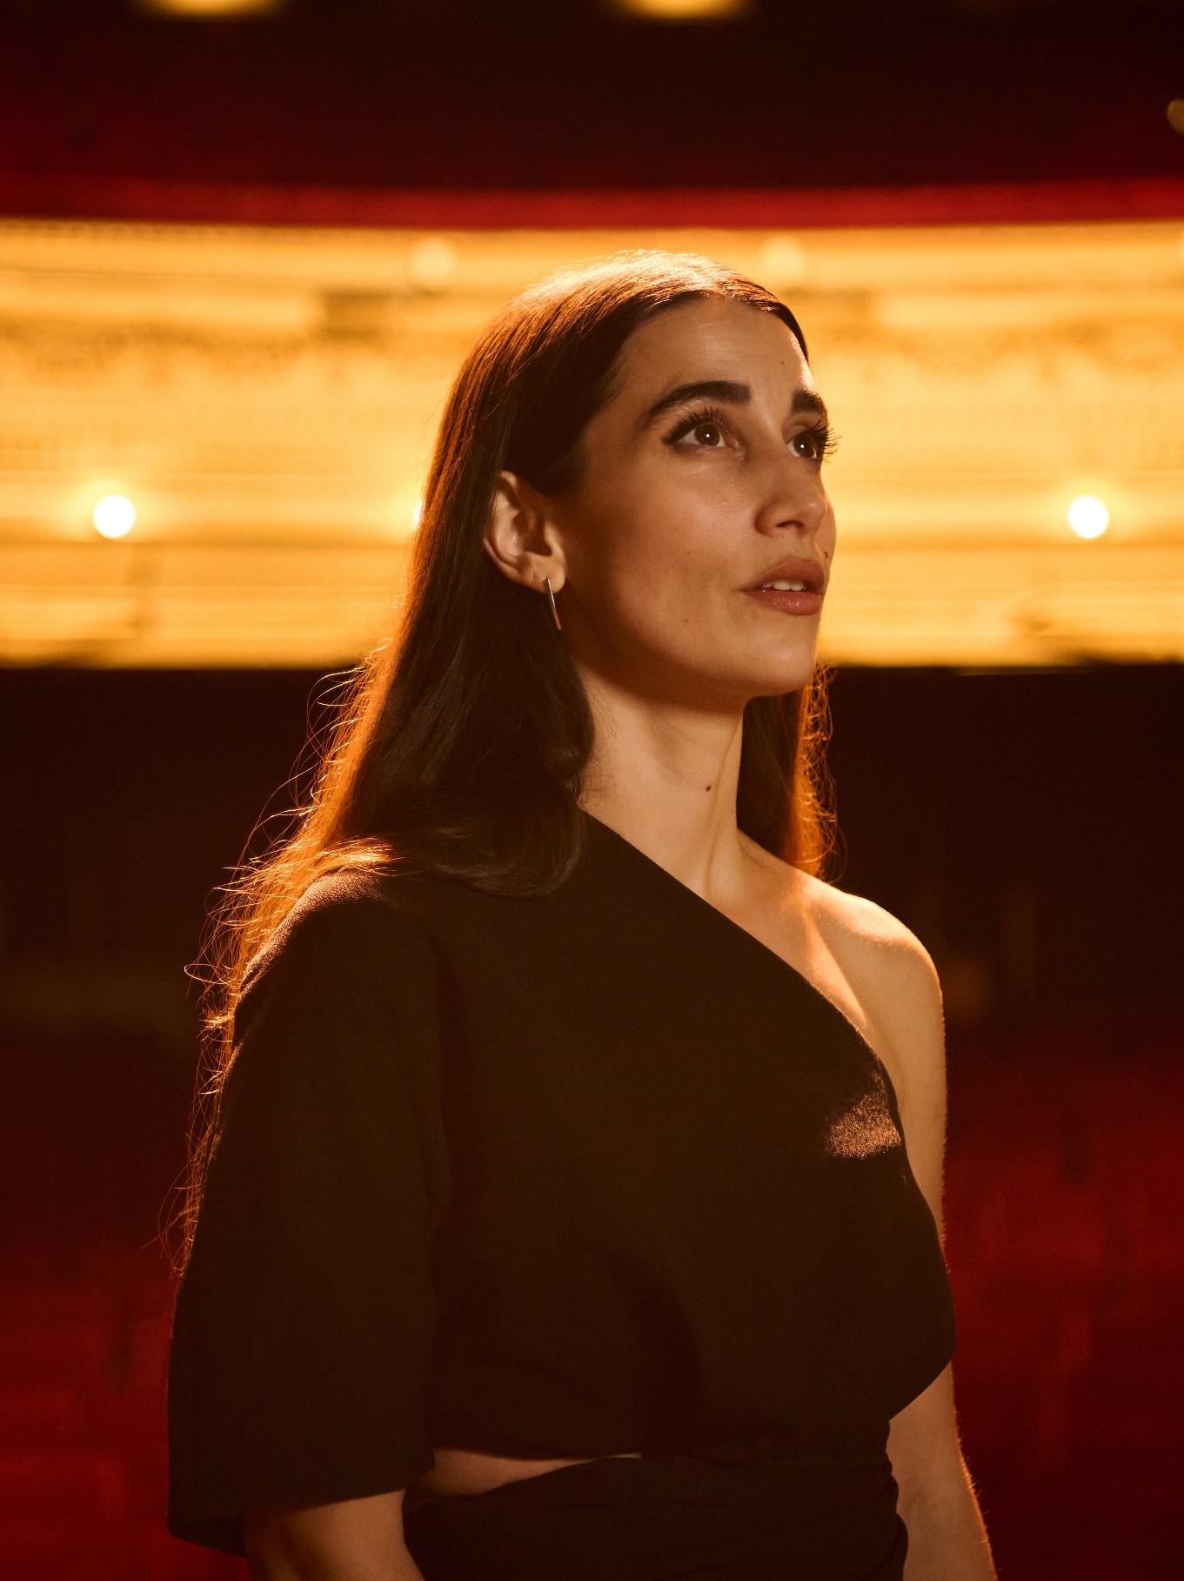

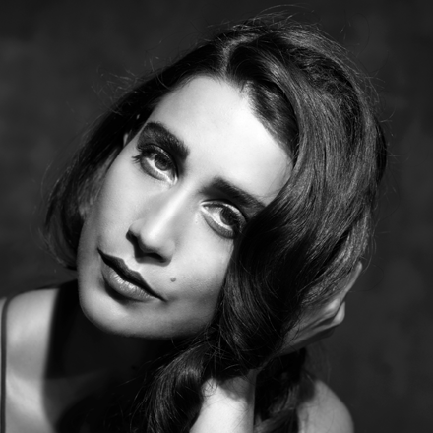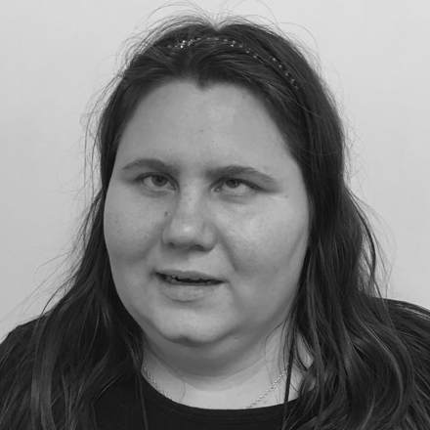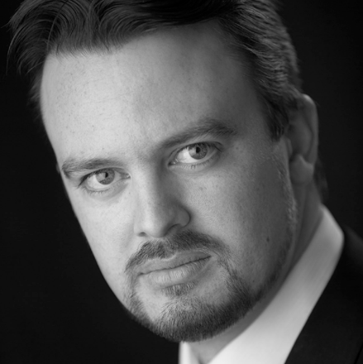

Elena Perroni

Iolanta

Praised for her “velvet soprano voice” (Philadelphia Inquirer), Elena Perroni has gained recognition on the international stage. Hailing from Western Australia, Perroni has made regular appearances with the Philadelphia Orchestra in title roles such as Iolanta (Iolanta, Tchaikovsky), Rusalka (Rusalka, Dvorak), Tatyana, (Eugene Onegin, Tchaikovsky) and Berlioz’s Les Nuits d’ete. Perroni made her opera debut with Opera Philadelphia in Charlie Parker’s Yardbird (Schnyder). As Doris Parker, she performed in the first opera to be performed at the legendary Apollo Theatre in New York City before reprising the role at English National Opera in 2017. Debuting in
her home country as Mimi (La
bohème, Puccini) with West Australian Opera in 2017, she then returned the following year as Violetta Valéry in Verdi’s La traviata. Elena’s 2020/2021
included her Carnegie Hall debut in Mozart’s Vesperae Solennes, Duke Theater Time Square Prokofiev - Five Poems of Anna Akhmatova.
She is the first Australian opera graduate of one of the most prestigious institutes of
music, Curtis Institute of Music, where she graduated with the Festorazzi Scholarship for most promising vocalist.

Grace King

Queen Iolanta

Grace King is a 36-year-old singer, actress and public speaker who has been totally blind from birth.
She has been singing since the age of five and public speaking for just about as long. Grace started acting as a child in church plays and participated in community theatre throughout high school. She also co- directed plays for the Wisconsin Centre for the Blind and Visually Impaired when she was a teenager.
Grace starred in the show Playtime with Grace and Fergus presented at His Majesty’s Theatre as part of the 2019 Perth Fringe Festival. She was also the voice of Ready to Role RPG Dice Roller which was released in March this year.
The winner of the first ever WA Ability Idol, Grace has also performed at the Sampav Disabled Arts Festival in India and various other local events here in Perth.

Paul O’Neill

Count Vaudémont

Australian tenor Paul O’Neill has forged a compelling international career performing throughout Europe and Australasia. In 2022, he sings Cavaradossi (Tosca), Alfredo (La traviata) and Count Vaudémont (Iolanta) for West Australian Opera and is tenor soloist in Britten’s War Requiem for WASO.
Most recently, Paul sang Don José (Carmen), Turiddu
(Cavalleria rusticana) and Canio (Pagliacci) for West Australian Opera, Rodolfo (La bohème), Narraboth (Salome) and Alfredo for Opera Australia, the title role in Faust for Theater Münster, Pinkerton (Madama Butterfly) throughout China and Cavaradossi in both Perth and Magdeburg. He has sung Don José at the Glyndebourne
Festival; Laca (Jenůfa) for Opéra de Lille; Rodolfo for Halle Opera and West Australian Opera; Elvino (La sonnambula) and Laca with Graz Opera.
Other roles include: The Duke (Rigoletto) with Opera Holland Park, Opera Australia, West Australian Opera, Staatstheater Karlsruhe and Staatstheater Mainz; Turriddu, Cavaradossi, and Carlo VII (Giovanna d´Arco) for Theater Bielefeld; Jason (Médée) for Theater Bielefeld and Staatstheater Mainz and The Italian Tenor (Der Rosenkavalier) for Berlin Staatsoper.

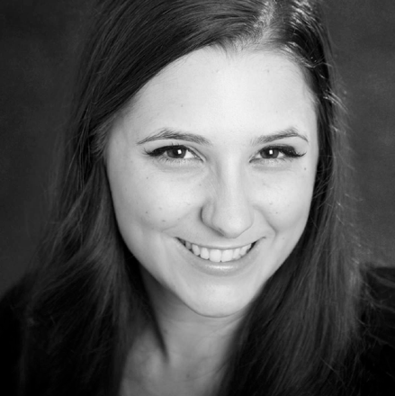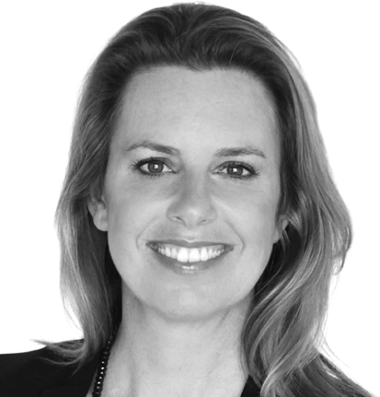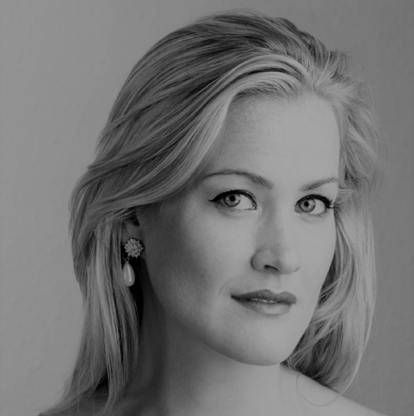

Chelsea Burns

Brigitte

Chelsea Burns is an Australian soprano. Chelsea was a 2020- 2021 member of the Wesfarmers Arts Young Artist program at West Australian Opera. She made her solo debut with the company in 2020 as Lucy in Menotti’s The Telephone.
She completed her Master of Music at the Royal Northern College of Music and her stage credits at the RNCM include Carmen in a concert version
of Bizet’s Carmen, Louise in Offenbach’s La vie Parisienne, and Didymus in Handel’s Theodora.
Over 2018, Chelsea worked with Opera North in Leeds, UK. She shadowed the role of Kate Pinkerton in Tim Albery’s
production of Puccini’s Madama Butterfly and was a part of their Chorus Mentorship Scheme.
Before moving to England, Chelsea graduated from the prestigious Western Australian Academy of Performing Arts in 2014 with a Bachelor of
Music and again in 2015 with a Graduate Diploma of Music. Her stage credits at WAAPA include the Witch in Humperdinck’s Hansel and Gretel, Marianna
in Ricci’s La serva e l’ussero, Oberon in Britten’s A Midsummer Night’s Dream, and Cecilia March in Adamo’s Little Women.

Fiona Campbell

Laura

Fiona Campbell is one of Australia’s most versatile and beloved classical singers - the winner of the national Limelight Award for Best Solo Performance 2011 and vocal winner of the ABC Young
Performer of the Year Award and the ASC Opera Awards.
Fiona sings regularly as a principal artist with all of the major ensembles and orchestras in Australia and with Opera Australia, Opera Queensland and West Australian Opera.
Her international collaborators have included the Brodsky Quartet, Tokyo Philharmonic, Manchester Camerata, Prague Chamber Orchestra, Hong Kong Philharmonic and Glyndebourne Festival Opera.
She was Associate Artist for José Carreras in Japan, Korea and Australia and for Barbara Bonney in Tokyo and London. In 2021, she sang Hippolyta in A Midsummer Night’s Dream for The Adelaide Festival and was soloist with the Australian String Quartet and the Queensland and West Australian Symphony Orchestras. In 2022, she returns to WASO and the QSO and appears as Laura (Iolanta) and Flora (La traviata) for West Australian Opera.

Brigitte Heuser

Marta

New Zealand born mezzo- soprano Brigitte Heuser began her classical vocal studies at the New Zealand School of
Music and furthered her operatic training at the Australian Opera Studio before gaining a Master of Arts in Performance Voice at the Wales International Academy of Voice. Brigitte was an emerging artist for New Zealand Opera where she was awarded the Circle 100 prize.
Brigitte has performed opera, concert, and cabaret across Europe and Australasia. She has sung with New Zealand Opera, Opernloft Hamburg, Wanderlust Theatre NZ, the International Foundation for Arts and Culture in Japan, and at the BBC Proms at the Royal
Albert Hall in London. She was a founding member of the operatic ensemble The Cast performing in theatres across Europe.
Brigitte’s operatic repertoire includes Hänsel, Hänsel und Gretel (Humperdinck); Dorabella, Così fan tutte, Cherubino, Le Nozze di Figaro; Annio, La Clemenza di Tito; Idamante, Idomeneo (Mozart); Maddalena, Rigoletto (Verdi); Aloes,
L’Etoile (Chabrier); Jenny Diver,
Threepenny Opera (Weill); Olga, Eugene Onegin (Tchaikovsky) and Katisha, The Mikado (Gilbert and Sullivan).

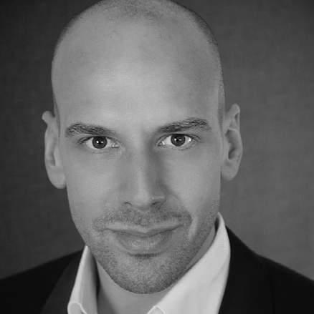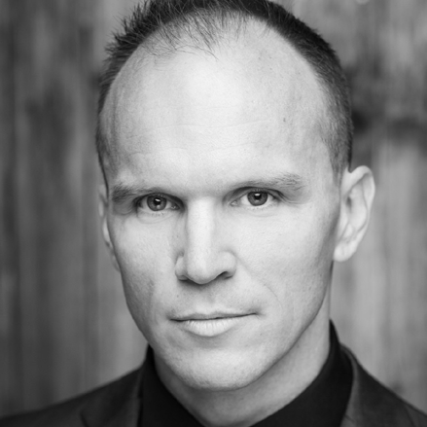

Lachlann Lawton

Duke Robert

Lachlann Lawton is an Australian and English Baritone. He was
a 2020/2021 Wesfarmers Arts Young Artist and Bendat Scholarship winner with West
Australian Opera. In WAO2022 Lachlann will perform the roles of Duke Robert (Iolanta), The Poet (Prima la Musica by Salieri), Sciarrone (Tosca) and Marchese d’Obigny (La traviata).
In 2022, Lachlann will also perform Marcello (La bohème) and Sonora (La Fanciulla del West) with Freeze Frame Opera.
Previously with WAO, Lachlann has performed the title role in Elijah, Fiorello and the Soldier (The Barber of Seville), Ben (The Telephone by Menotti), and covered Guglielmo (Così fan tutte), Count Almaviva (Le Nozze di Figaro), and Silvio (Pagliacci).
Lachlann completed a Masters of Music at the Royal Northern College of Music in Manchester and studied with baritone Quentin Hayes. At the RNCM Lachlann performed the roles of The Pilgrim (The Pilgrim’s Progress), Marco and cover Gianni Schicchi (Gianni Schicchi), Peter (Hansel and
Gretel) and Escamillo (Carmen).
Lachlann has a Bachelor of Music in Classical Performance and a Graduate Diploma
of Music from the Western Australian Academy of Performing Arts (WAAPA).

Adrian Tamburini

King René

Adrian has enjoyed a long and varied career as an opera singer, concert performer, music educator, director and producer. In 2017, Adrian was the winner of Australia’s
prestigious singing award, the Australian Opera Awards (YMF, MOST). His singing has featured on cinema releases of opera, DVD, international recordings, motion picture soundtracks, radio, and television. He is proud to have worked with companies such as Opera Australia, Pinchgut Opera, West Australian Opera, Melbourne Opera, Lost and Found Opera,
Melbourne Symphony Orchestra, Zelman Symphony Orchestra, Sydney University Graduate Choir, Melbourne Bach Choir, West Australian Symphony Orchestra, and the Canberra Symphony Orchestra. Over
the past few years, he has focused on sharing his passion for music by teaching the next generation of musicians at Pure Harmony Music Studio in Melbourne. Adrian has worked with renowned conductors
and directors such as Asher Fisch, Andrea Molino, Andrea Battistoni, Jonathan Darlington, Pietari Inkinen, Carlo Montanaro, Renato Palumbo, Guillaume Tourniaire, David McVicar, and Francesca Zambello, as well as Australians Jessica Cottis, Barrie Kosky, Bruce Beresford, and John Bell.

Simon Meadows

Ibn-Hakia (The Doctor)

Baritone Simon Meadows studied at The Victorian College of the Arts graduating with a BA (Music) and then going on to
do a Grad Dip (Opera). He was the recipient of The Armstead singing scholarship for the music lover’s society as well as the Mabel Kent singing Scholarship at VCA.
He has performed as a principal artist for Opera Australia, Victorian Opera, Melbourne Opera and Chambermade Opera. While living abroad
in the UK, he also performed as a soloist in London, Berlin and Wexford Ireland in the
prestigious festival held annually.
On the concert stage, Simon has been a soloist for the Melbourne Symphony Orchestra, Orchestra Victoria, Royal Melbourne Philharmonic and Sydney Philharmonic orchestras as well as the Tasmanian Symphony Orchestra.
Career highlights include the title role in Verdi’s Macbeth, Alberich in Wagner’s Das Rheingold and Escamillo in Bizet’s Carmen.
Mozart roles include both Figaro and the Count in Le Nozze di Figaro and Guglielmo in Così fan tutte.

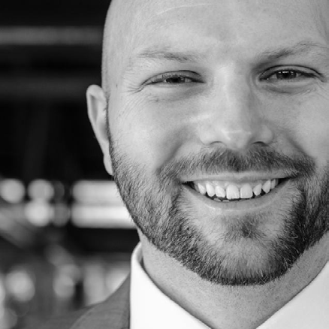

Callen Dellar

Bertrand

Callen started his studies at WAAPA before moving to Sydney to complete an
Advanced Diploma of Opera from the Sydney Conservatorium of Music.
Upon completing his studies he then joined Opera Australia and toured with OzOpera singing the roles of Figaro in The Barber of Seville and Peter in Hansel and Gretel. He then spent the next 12 years performing in numerous productions for Opera Australia in the chorus for both main stage productions and Handa Opera on Sydney Harbor. Upon moving back to Perth six years ago he rejoined the West Australian Opera Chorus where he started his professional career in 1997.
Other roles he has performed include Masetto & Leporello, Don Giovanni (Sydney) Mephistopheles, Faust (Sydney), Bastien, Bastien und Bastienne (Sydney) Antonio & Bartolo, Le nozze di Figaro (Sydney) and Papageno, Die Zauberflote (Sydney).

Matthew Reardon

Alméric

Tenor Matthew Reardon is a principal artist with Opera
Australia. He is a graduate of The Western Australia Academy of Performing Arts and The Dame Nellie Melba Opera Trust Program. Matthew furthered his studies abroad working with famed Mezzo Soprano Marilyn Horne at The Music Academy of the West in Santa Barbara, California. He completed a Masters of Opera at The Wales International Academy of Voice.
Matthew made his debut in the first Indigenous opera Pecan Summer by Yorta Yorta soprano Deborah Cheetham singing
the role of Young Man 1. Other professional engagements include Pinkerton in Madame Butterfly with Opera Australia, Cavaradossi in Tosca with the Australian Discovery Orchestra, Ferrando in Mozart’s Così fan tutte, Rodolfo in Puccini’s La bohème and Vašek in The Bartered Bride by Smetana in California.
Matthew has also been a chorus member in 3 different productions in Handa Opera on Sydney Harbour (HOSH).
Most recently Matthew toured Australia singing Don José in Opera Australia’s National tour of Carmen.
This is Matthew’s principal artist debut with West Australian Opera.

WEST AUSTRALIAN OPERA CHORUS

* Celebrating over 10 years
** Celebrating over 20 years

SOPRANOS MEZZO SOPRANOS

TENORS

BASSES

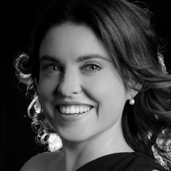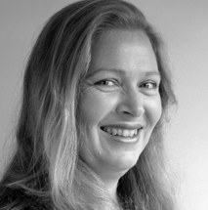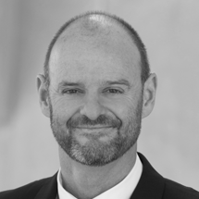

Alexandra Bak *

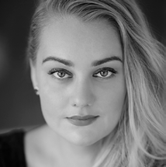
Leilah Fox *

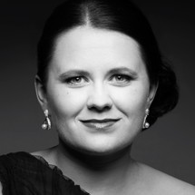
Jillian Halleron

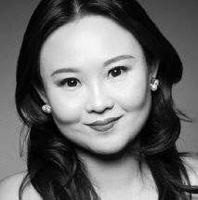
Yann Kee

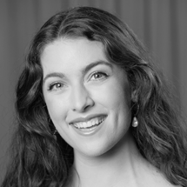
Bella Marslen

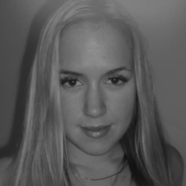
Lucy Mervik *

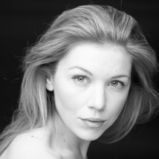
Prudence Sanders

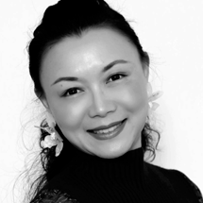
Xiaojia Zhang *
Helen Brown *

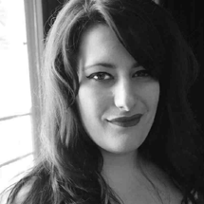
Caitlin Cassidy

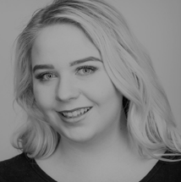
Morgan Halket

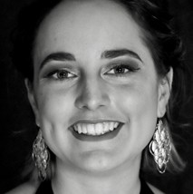
Sophie Herbert

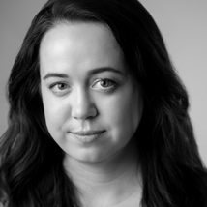
Chelsea Kluga

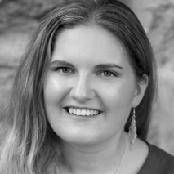
Claire Lane

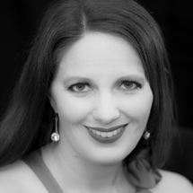
Courtney Pitman *
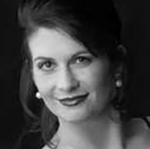
Elizabeth Vale **
Ammon Bennett

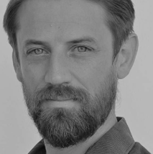
Jonathan Brain *

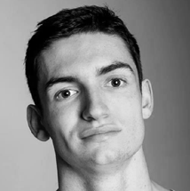
Tom Buckmaster

Ry Charleson

Perry Joyce

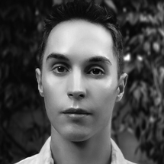
Jason Kroll

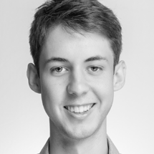
Euan Macmillan

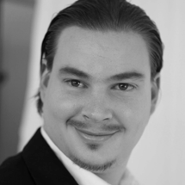
Joshua Mitting
Mark Alderson **
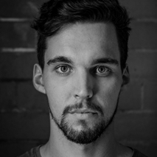
Jake Bigwood
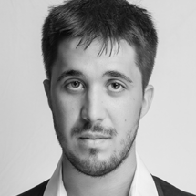
Kyle Garces
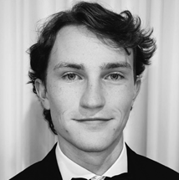
Lachlan Higgins
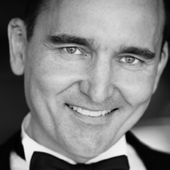
Robert Hofmann *
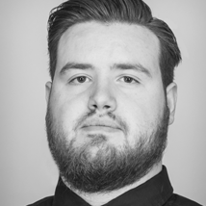
Brett Peart
David Penco *
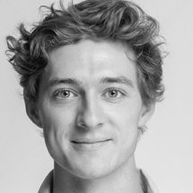
Keaton Staszewski-Hose

WEST AUSTRALIAN SYMPHONY ORCHESTRA

VIOLIN
Semra Lee-Smith
A/ Assoc Concertmaster
Kylie Liang
Assoc Principal 2nd Violin
Kate Sullivan
Assistant Principal 2nd Violin
Stephanie Dean Beth Hebert Alexandra Isted
Christina Katsimbardis Akiko Miyazawa Lucas O’Brien
Melanie Pearn Jolanta Schenk Jane Serrangeli Bao Di Tang Cerys Tooby

VIOLA
Daniel Schmitt Nik Babic Benjamin Caddy Rachael Kirk Helen Tuckey

CELLO
Eve Silver* Shigeru Komatsu Oliver McAslan Fotis Skordas

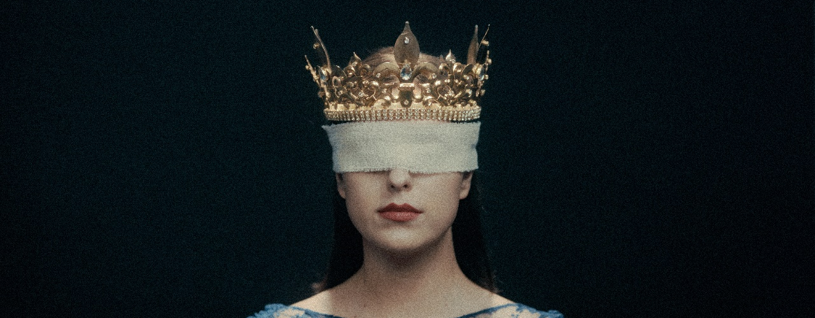
DOUBLE BASS
Andrew Sinclair* Mark Tooby Giovanni Vinci°

FLUTE
Andrew Nicholson
Anonymous
Mary-Anne Blades
Anonymous
Tresna Stampalia^

OBOE
Liz Chee A/Principal Oboe Annabelle Farid°

COR ANGLAIS
Leanne Glover
Sam & Leanne Walsh

CLARINET
Allan Meyer
Lorna Cook

BASSOON
Adam Mikulicz

CONTRABASSOON
Chloe Turner
Stelios Jewellers

HORN
Margaret & Rod Marston
David Evans
Ben Messenger° Robert Gladstones Principal 3rd Horn Julia Brooke

TRUMPET
Brent Grapes
Anonymous
Peter Miller

TROMBONE
Joshua Davis
Dr Ken Evans AM &
Dr Glenda Campbell-Evans
Liam O’Malley

BASS TROMBONE
Philip Holdsworth

TUBA
Jason Catchpowle^

TIMPANI
Alex Timcke

HARP
Yi-Yun Loei^ Will Nichols^

CELEBRATING A SHARED COMMITMENT TO CREATIVITY PROUD SUPPORTERS OF WEST AUSTRALIAN OPERA SINCE 2009

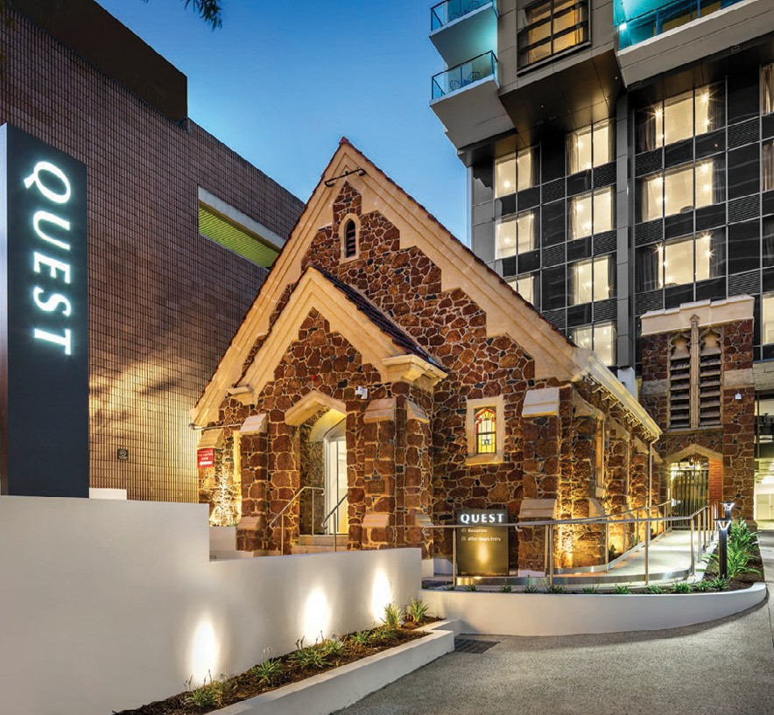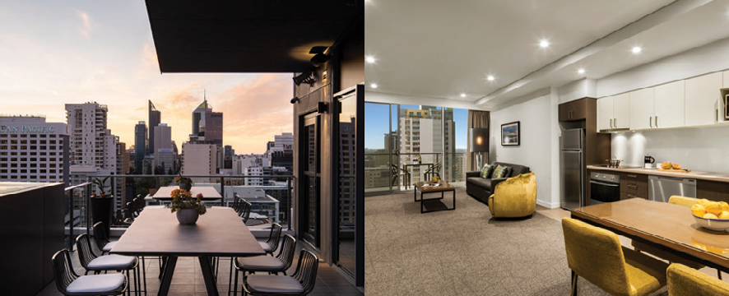

ENJOY
THE SHOW
Proud supporter of West Australian Opera

FEEL AT HOME AT
QUEST EAST PERTH

Friends of the West Australian Opera choose to stay at Quest East Perth. A new apartment hotel on Adelaide Terrace with 128 self-contained studio, one and two bedroom apartments.

✔ 24 hour onsite management
✔ Newly opened CEO SkyLounge with a rooftop bar
✔ Secured parking next door
✔ Onsite conference facilities
✔ Onsite gym

Visit www.questeastperth.com.au
or call (08) 6210 6000

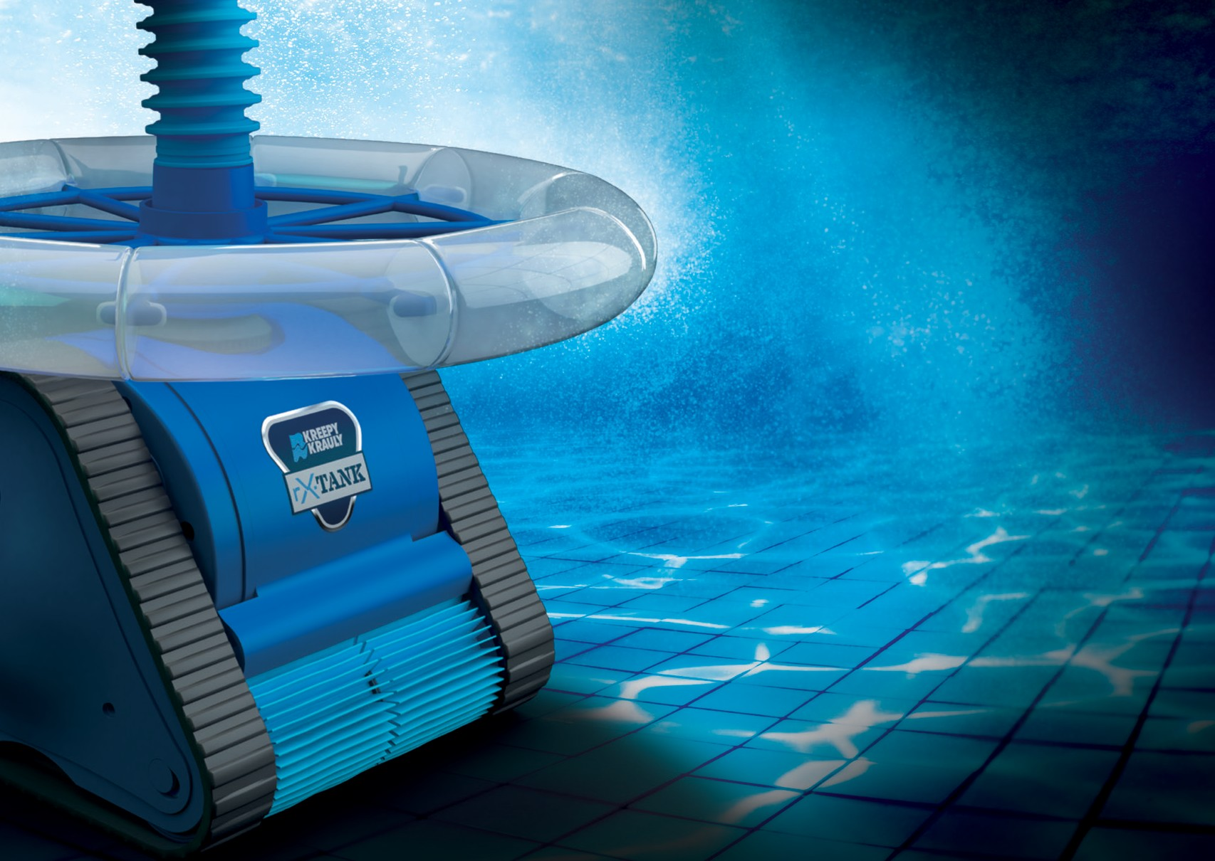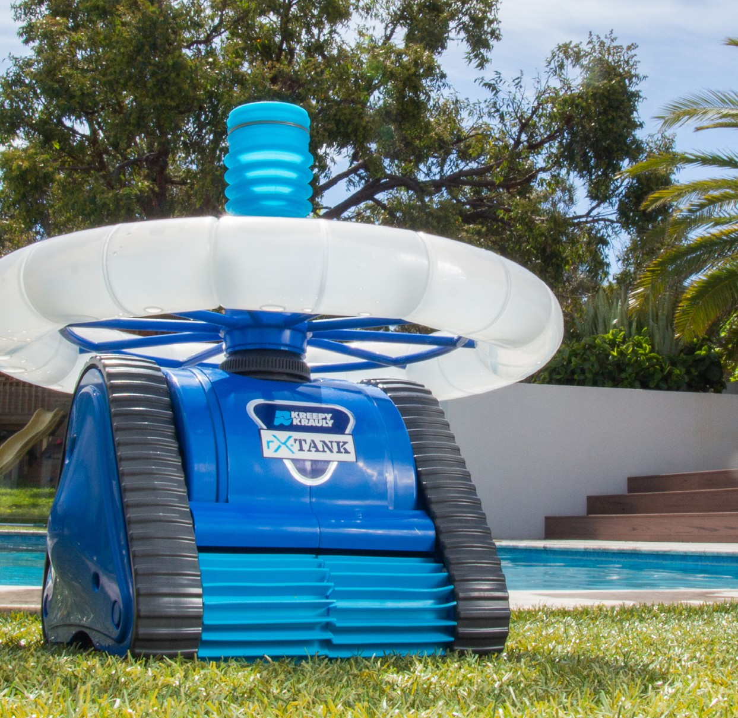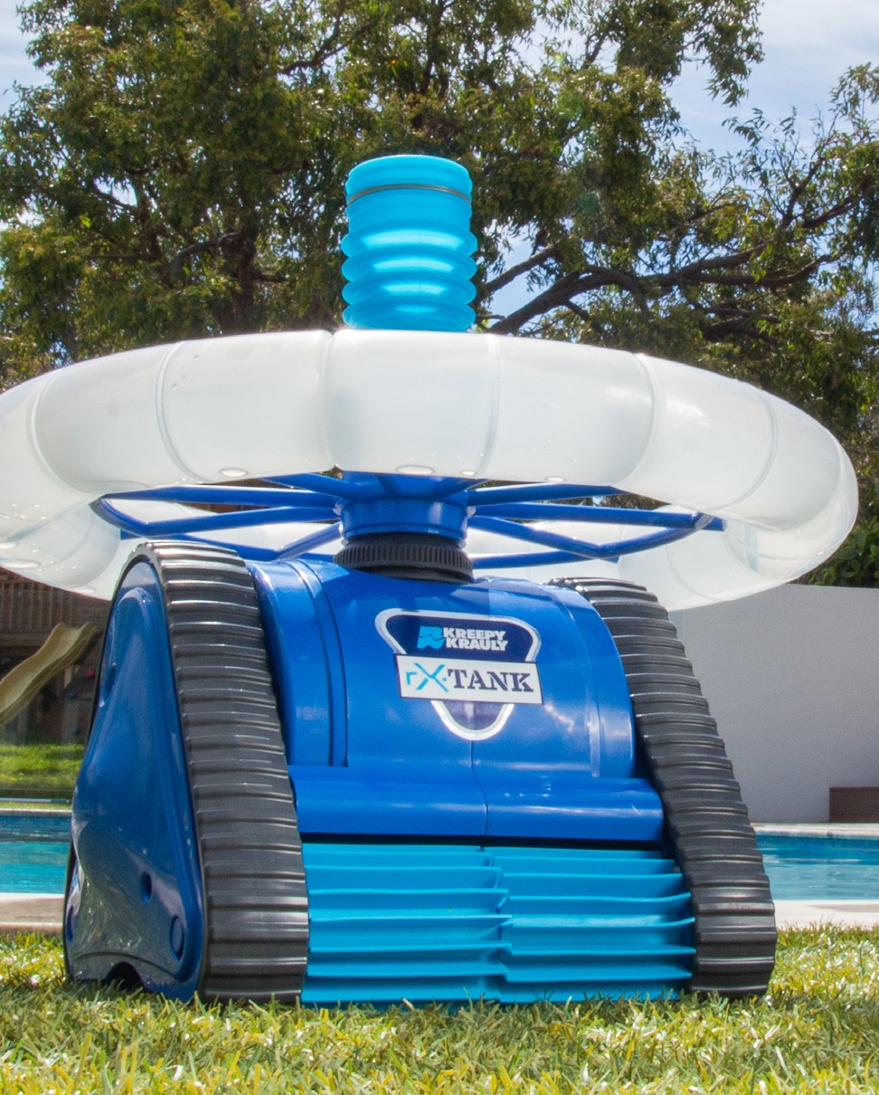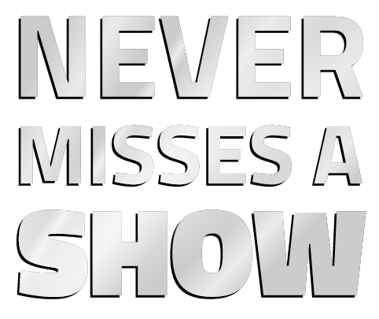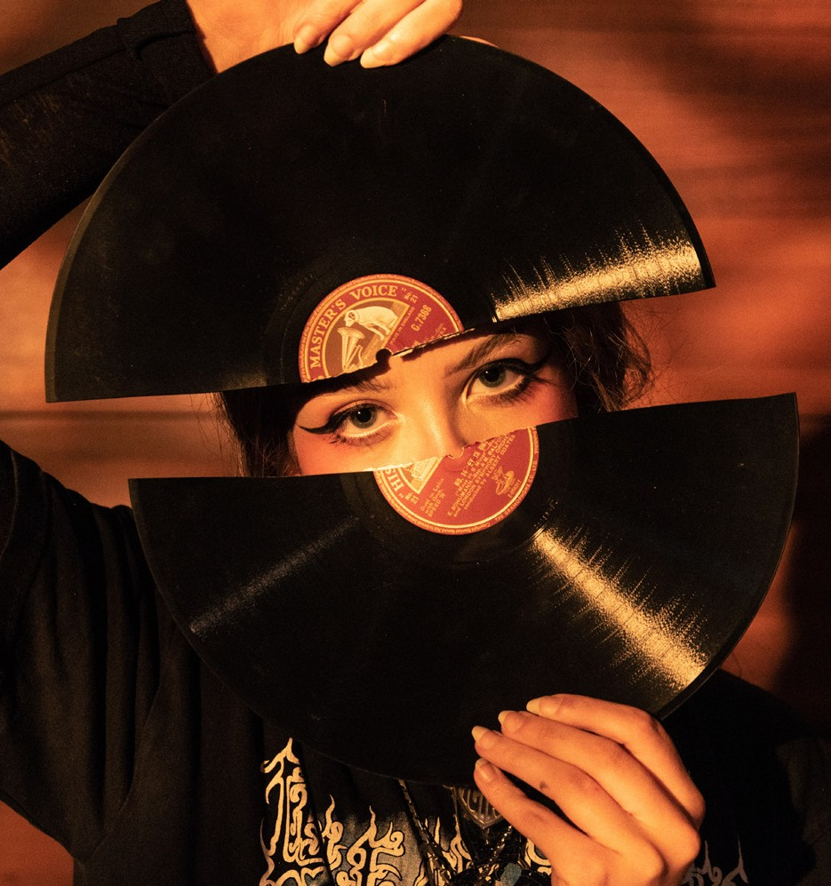
kreepykrauly.com.au
Proudly Australian Made & Owned

UWA CONSERVATORIUM OF MUSIC
Proud Tertiary Education Partner of the West Australian Opera
As one of Australia’s leading music programs, in one of the world’s leading universities, we create the future leaders of the Arts community.
music.uwa.edu.au
CRICOS Provider Code: 00126G DCS 659809900

THANK YOU TO OUR DONORS

LEADERSHIP CIRCLE ($10,000+)
Dr. David Glance Warwick Hemsley AO
Dr Robert Larbalestier AO Leanne and Sam Walsh AO Anonymous (2)

PRINCIPAL PATRON ($5,000+)
Dr Dennis Hayward
The Robert Kimpton Family Annie & Neil Patrick
Angela Roberts
Dr Peter Simpson OAM Michael & Helen Tuite Marissa Casingal (Saog) & Martin Woodward (Jangyu) Anonymous (1)

BENEFACTOR ($2,500+)
Neil Archibald & Alan R. Dodge AM Catherine Ferrari
Dr. Maria Kailis Eleanor John Tessa La Mela Francis Landels Patrick Lilburne Dr Bryant Macfie Lisa Stewart Anonymous (2)

SUPPORTER ($1,000+)
Gaysie Atkinson
Dr Colin Binns & Dr Mi Kyung Lee Dr Peter & Mrs Rae Breidahl
Joan Carney Helen Carroll Frank Cooper AO Michael Cowie
John & Ann Dawson Michelle Edwards Lorraine Ellard
T & E Gerner
Kathryn Hogan & Graham Droppert Ulrich & Gloria Kunzmann
Simon Landers Ross & Fran Ledger Yuko Lucas
Karen Parfitt Kerry Sanderson Glenice Shephard
Kim & Keith Spence Clare Thompson Agatha Van Der Schaaf Karen Venard
Yannis Vrodos
Dr Chris & Mrs Vimala Whitaker
Diana Warnock & the late Bill Warnock Anonymous (9)

FRIEND ($500+)
Tom Aram
Cathy Bardon & Bob Cassie David & Lois Black Christine Burson
Carolyn Chard AM
Dr Douglas Clifford
Dr Graham Douglas & Brian Lindberg Peter Eadington
Sue Foster
Rosemary Grigg & Peter Flanigan Dr Rosalind Hampton
Cecilia Hastings Dr Penny Herbert Jennifer Jones Sue Joubert
Jock & Jennifer Laurie Darren Lewsen
Cathy & Cian Noonan Liane Papaelias Wendy Powles Jennifer Rankin Wayne Robinson Elizabeth Shelton
The Sherwood Family Diane Smith-Gander Margaret Stockton
Warren & Katharina Surtees Dr Peter Winterton
Alison Woodman Anonymous (6)

TRUSTS AND FOUNDATIONS
Bendat Family Foundation Crown Resorts Foundation Packer Family Foundation Wright Burt Foundation
The James Galvin Family Foundation Stan Perron Charitable Foundation Feilman Foundation

ANDREW AND NICOLA FORREST AO
The generous gift of FMG shares is testament to the Forrest’s commitment to a strong and vibrant arts sector in Western Australia.

BEL CANTO FUND
Thanks to the leadership donors of the Bel Canto Fund.

BEQUEST CIRCLE
Anita & James Clayton Lorraine Ellard
Ailsa West Anonymous (6)
Join our cast of supporters by donating online at waopera.asn.au. All donations over $2 are tax deductible.

VENUE ACKNOWLEDGEMENTS

PERTH THEATRE TRUST

Chair
Morgan Solomon

Board
Nadia van Dommelen Julian Donaldson Michelle Tremain Councillor Sandy Anghie Councillor Di Bain Councillor Clyde Bevan

Director General, Department of Local Government, Sport and Cultural Industries and General Manager, Perth Theatre Trust
Lanie Chopping

VENUE ADMINISTRATION

Venue Manager
Helen Stewart

Manager Venue Operations
Alexandra Lehmann

Event Operations Coordinator
Jenny Lee

Administration and Accounts Assistant
Fiona McNiece

Administration Assistant
Julianna Noonan

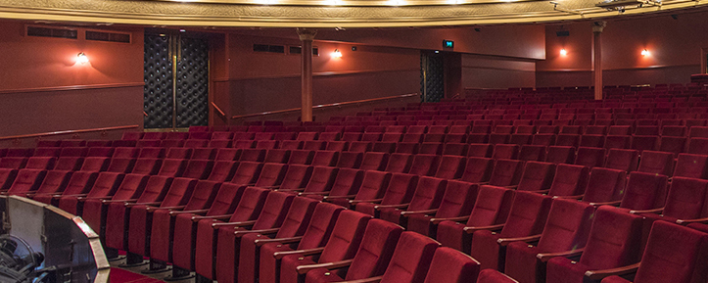
Box Office Supervisor
Jenny Franklin

Archivist
Ivan King OAM

VENUE TECHNICAL

Director of Technical Services
Mark Howett

Acting Director of Technical Services
Matthew Nankivell

Acting Deputy of Technical Services
Elliot Chambers

Audio Supervisor
Kieran O’Regan

Audio Visual Supervisor
Stacy Buegge

Staging Supervisor
Eoin O’Briain

Head Flyman
Steven De Vries

Lighting Supervisor
Shane Bowring and Peter Young

WEST AUSTRALIAN OPERA

BOARD
Andrew Pascoe (Chairman) Catherine Ferrari (Deputy Chair) Christiaan Heyning
Darren Lewsen Ingrid O’Brien Jan Stewart Janet Barnes Anthony Gianotti

VICE REGAL PATRON
The Honourable Kim Beazley AC, Governor of Western Australia

HONORARY LIFE MEMBERS
Dario Amara Julie Bishop
Richard Bonynge AC CBE Terry Bowen
Frank Cooper AO Erich Fraunschiel Colin Goddard Warwick Hemsley AO Francis Landels Bruce Martin AM Margaret McManus Dr Richard Mills AM Annie Patrick
Marilyn Phillips
Vincent A Warrener AM KHS

WAO STAFF

Executive Director
Carolyn Chard AM

Artistic Director
Christopher van Tuinen

Production Manager
Mandy Farmer

Artistic Administrator
Kate Larkins

Accountant
Debbie Byrnes

Education Manager
Terasa Letizia

Education Assistant
Gabriella Ibrahim

Partnerships Manager
Rachel O’Brien

Philanthropy Manager
Catherine Noonan

Marketing Manager
Danielle Barlow

Acting Marketing Manager
Scott Whinfield

Marketing Coordinator
Holly Langford-Smith

Media Consultant
Daniele Foti-Cuzzola

CRM Coordinator
Rachel Sait

Events Manager
Ginny van Tuinen

Events Assistant
Rebecca Bencivenni

Financial Accountant
Kris Adrian

Music Librarian
Allison Fyfe

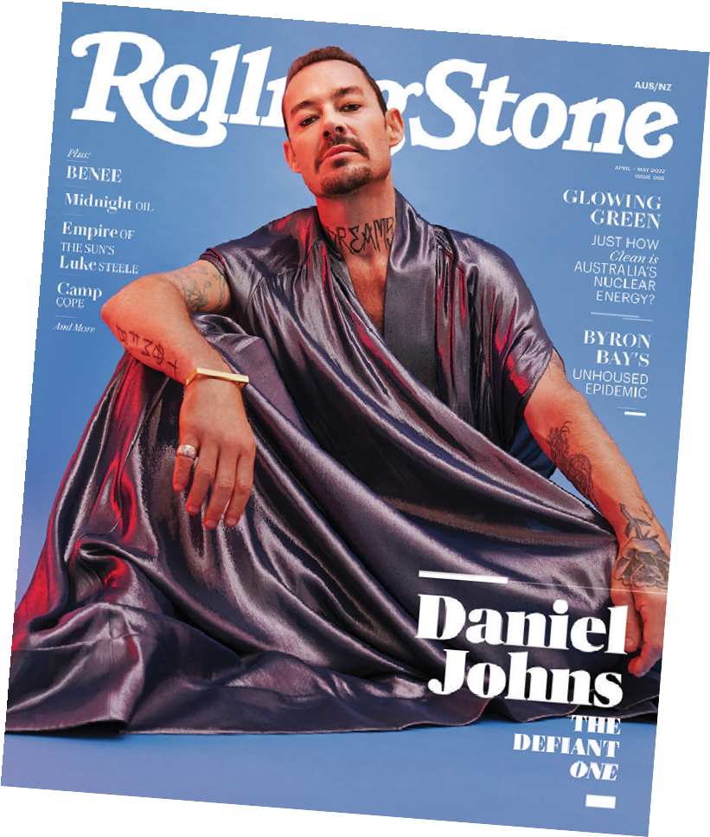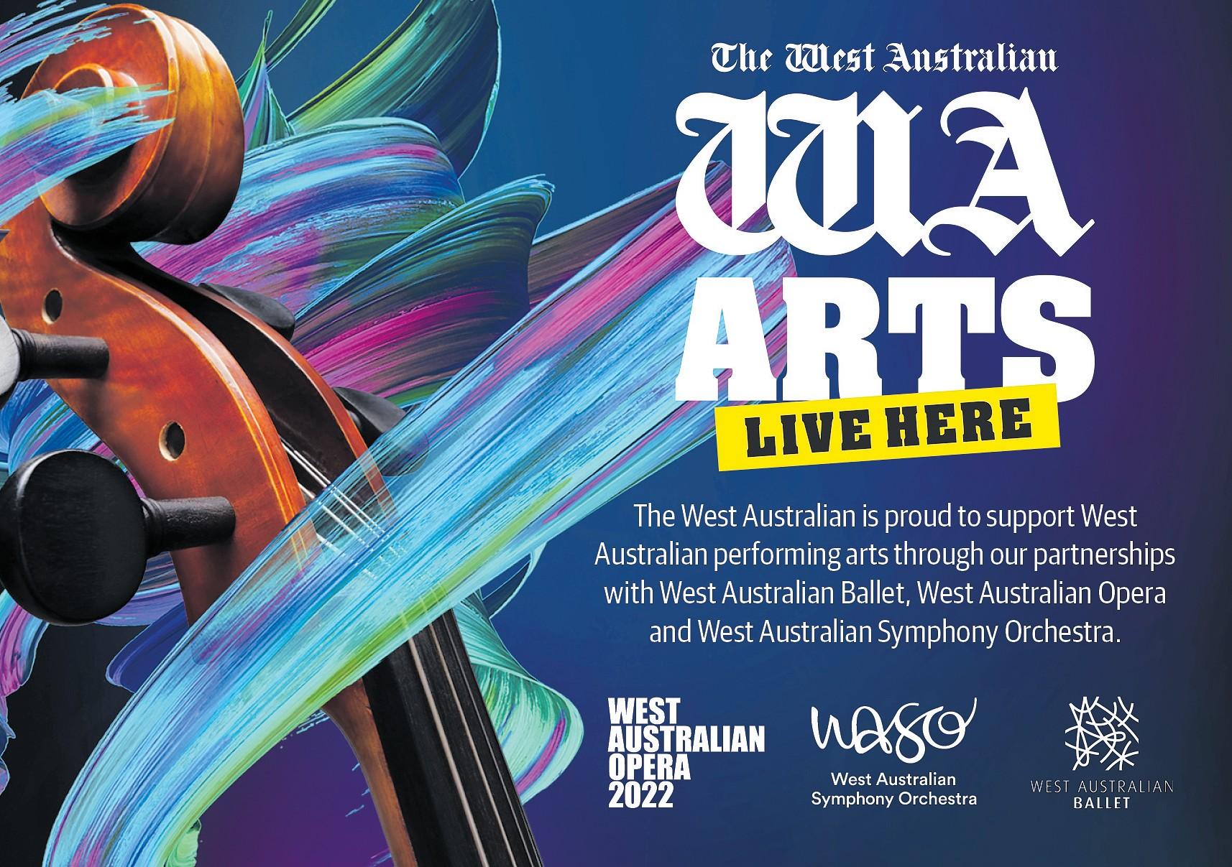

NEW ISSUE

OUT APRIL 4

HIS
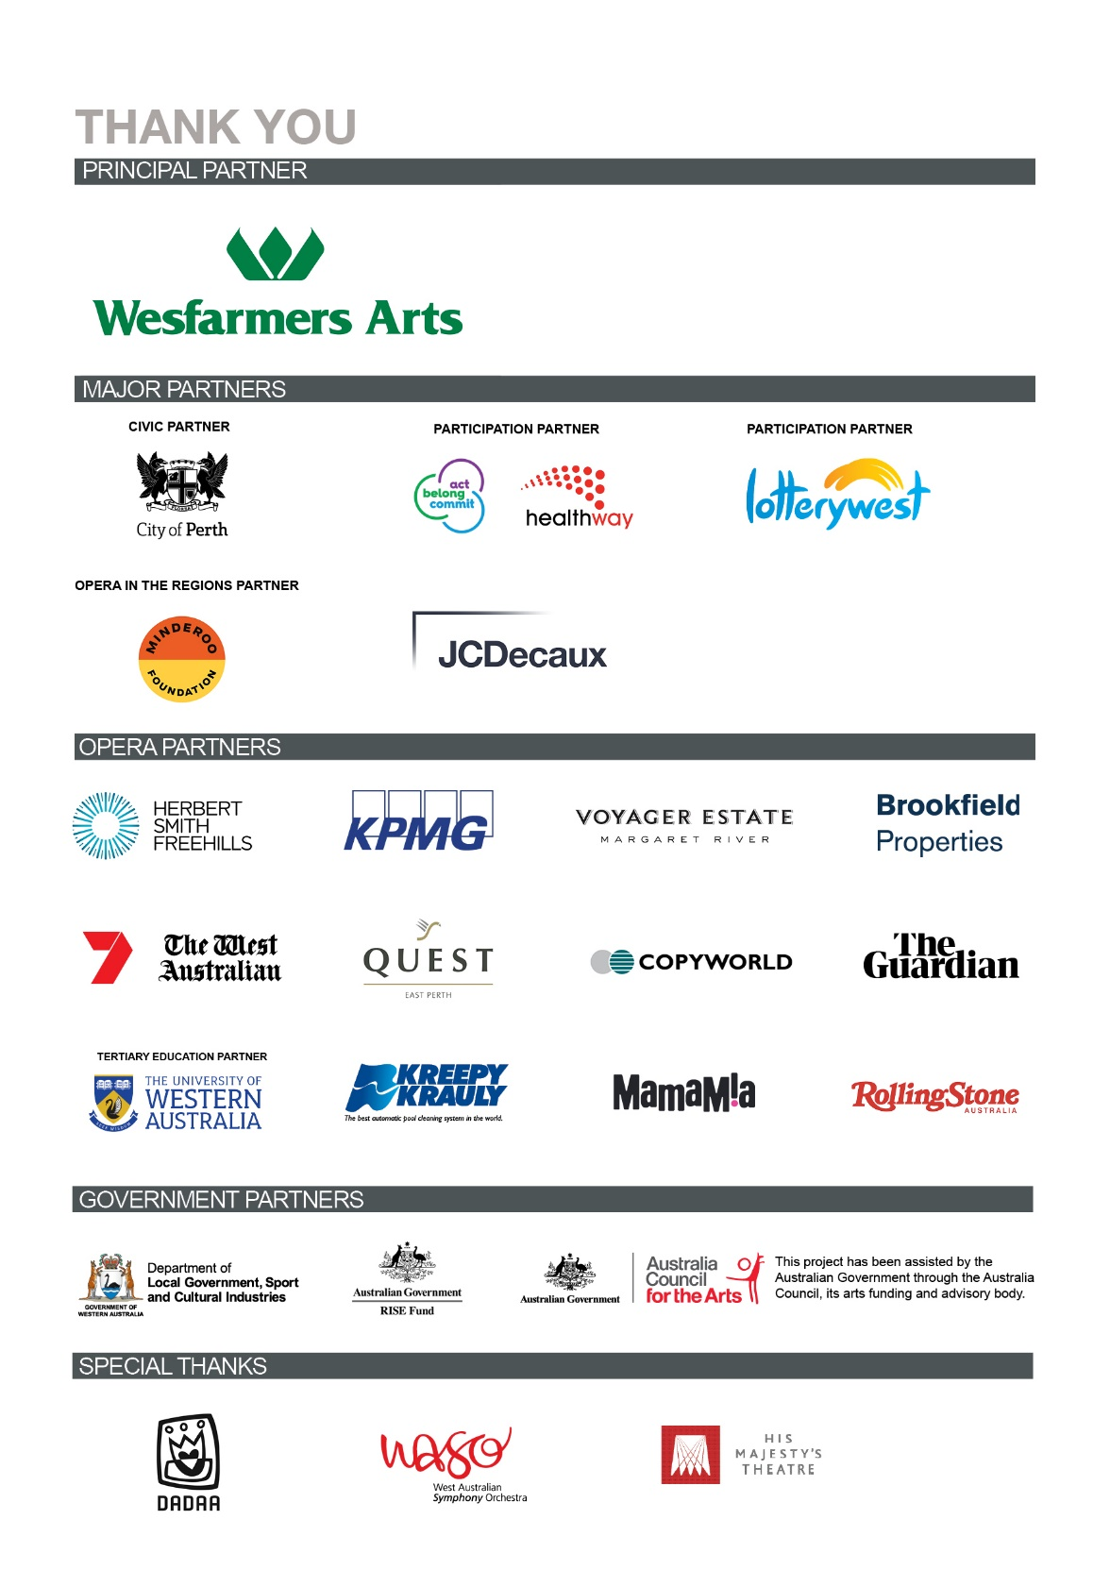

WEST AUSTRALIAN OPERA

West Australian Opera acknowledges the Traditional Owners of the land on which we work,
the Whadjuk people of the Noongar nation. We pay our respects to Elders past, present and emerging.

