THE DUEL
7.00PM | 12, 13, 14, 15 MAY 2022
FREQUENTLY ASKED QUESTIONS (FAQs))
WHEN IS IT?
7.00pm 12, 13, 14 and 15 May 2022

WHAT TIME CAN I ARRIVE?
The ballroom will be open from 7.00pm. Please arrive promptly to collect a drink on arrival and be seated at your table.

WHERE IS IT?
Government House Ballroom, Government House, 13 St Georges Terrace, Perth 6000

WHEN IS IT?
7.00pm 12, 13, 14 and 15 May 2022

DO I NEED A TICKET?
Yes. This is a paid ticketed event.
- All patrons need to present their tickets on entry to Government House.
- If you can’t locate your ticket, please contact the Box Office from which you purchased your ticket (Perth Theatre Trust on 6212 9292 or Perth Concert Hall on 9231 9999)

GETTING THERE
Where can I park?
Government House is located in Perth CBD. The closest carparks are located at
- Council House carpark – more information here
- Perth Concert Hall carpark – more information here

What public transport can I take?
Click here to plan your public transport journey with Transperth.

Where can I be dropped off?
There is a passenger drop off point on St Georges Terrace, outside Council House.
Please refer to the map below

Where do I enter the venue?
Entry to the venue is via the Council House laneway. Please refer to the map below
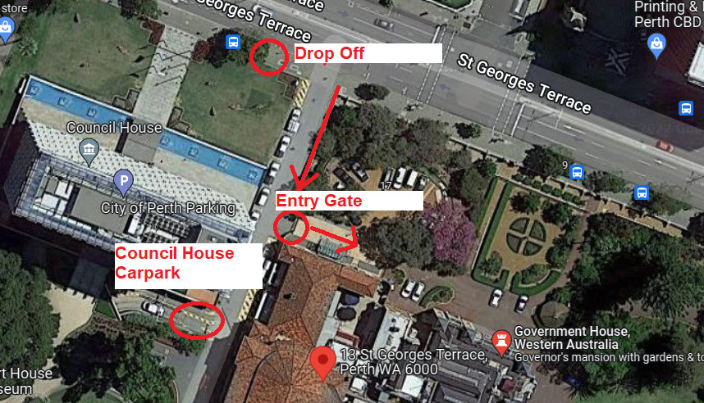

CAN YOU TELL ME ABOUT THE EVENT?
Is there a program?
A synopsis sheet and cast list will be available at your seat, and online at www.waopera.asn.au

Which singers are performing?
Full cast and creatives list available online at www.waopera.asn.au

Der Schauspieldirektor – Mozart

Mr Cash Matthew Reardon
Madame Heart Prudence Sanders
Mademoiselle Silverclang Emma Pettemerides

Prima la musica e poi le parole – Salieri

Donna Eleonora Prudence Sanders
The Maestro Jake Bigwood
The Poet Lachlann Lawton
Tonina Emma Pettemerides

What are the running times?
7.00pm Welcome beverage and canapes
7.30pm Entrée
8.15pm Der Schauspieldirektor (Mozart)
8.45pm Mains followed by petit fours
9.45pm Prima la musica e poi le parole (Salieri)
10.25pm Event concludes

Where can I view the menu?
Please click here to download
Can you cater to my dietary requirements?
Yes, we cater to all dietary requirements. You will be contacted by box office to confirm your requests.

What do I wear?
Whilst there is no official dress code, you are welcome to dress up. During recent pandemic lockdowns and ‘slowdowns’, you may have watched some of our favourite shows such as Bridgerton, Downton Abbey or The Crown. If you feel like wearing something dressy or showy you are welcome; evening dress, black tie, a costume, or your favourite outfit.

What is the lockout policy?
There is no lockout for this performance.

Who can I contact for more information on the event?
Further details are available at www.waopera.asn.au
You can also contact us directly here or you can check WAO’s Facebook and Instagram pages.

SEATING
Where will I be seated?
When you book tickets, you will be allocated to a table number.
- Your tickets will state which table you have been allocated to sit at.
- There will be a seating plan provided at the venue.
- Each table will be demarcated with signage and Front of House staff can assist you.
- There will be a named place card at your seat.

Can I change seats at my table?
No, we ask you remain in your allocated seat to enable dietary requirements to be provided to correct patrons.

Can I change tables?
No, you must sit at the table which has been allocated to you and that is stated on your tickets.

ONSITE FACILITIES
Will there be a cloakroom?
Yes, there will be a cloakroom located inside the venue entrance hall. Front of House can assist you.

Where are the bathrooms located?
The bathrooms are located to the right as you enter the venue entrance hall.

What should I do if I have lost property?
Please alert a Front of House staff member. After the event, please email administration@waopera.asn.au

COVID-19 SAFETY
What COVID-19 safety measures are in place?
Please ensure you comply with ‘standard safety measures’ including maintaining your own social distancing, using hand sanitiser and staying home if you are unwell.
- Hand sanitiser stations readily available
- Ongoing frequent deep cleaning regimes across all areas of the venue
- COVID-19 safety trained staff in all areas
- Face masks available on request

For the latest WA State Government COVID-19 updates please click here
What happens if I am unwell?
- Please do not attend this event if you are unwell.
- Please contact bookings@waopera.asn.au to cancel your tickets if you cannot attend.

THE DUEL is proudly presented by West Australian Opera in association with The University of Western Australia Conservatorium of Music.

